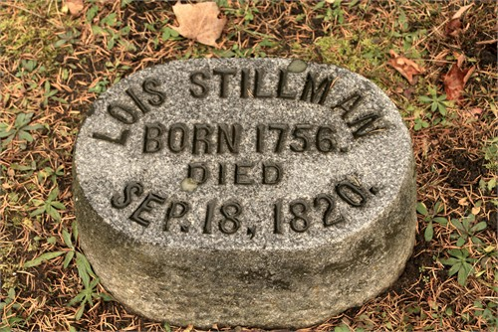
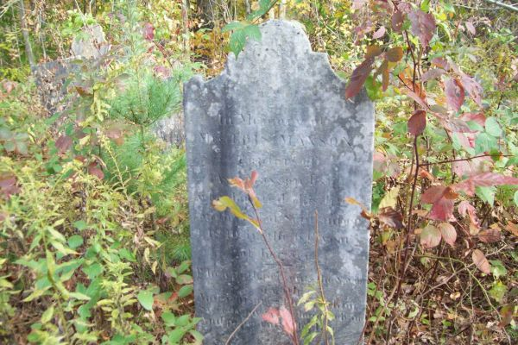
In Memory of
Lois Maxson
Wife of
Asa Maxson
Tombstone:
Stillman Village Cemetery
Petersburg, Rensselaer Co, NY

Cenotaph:
Union Cemetery
Adams Center, Jefferson Co, NY
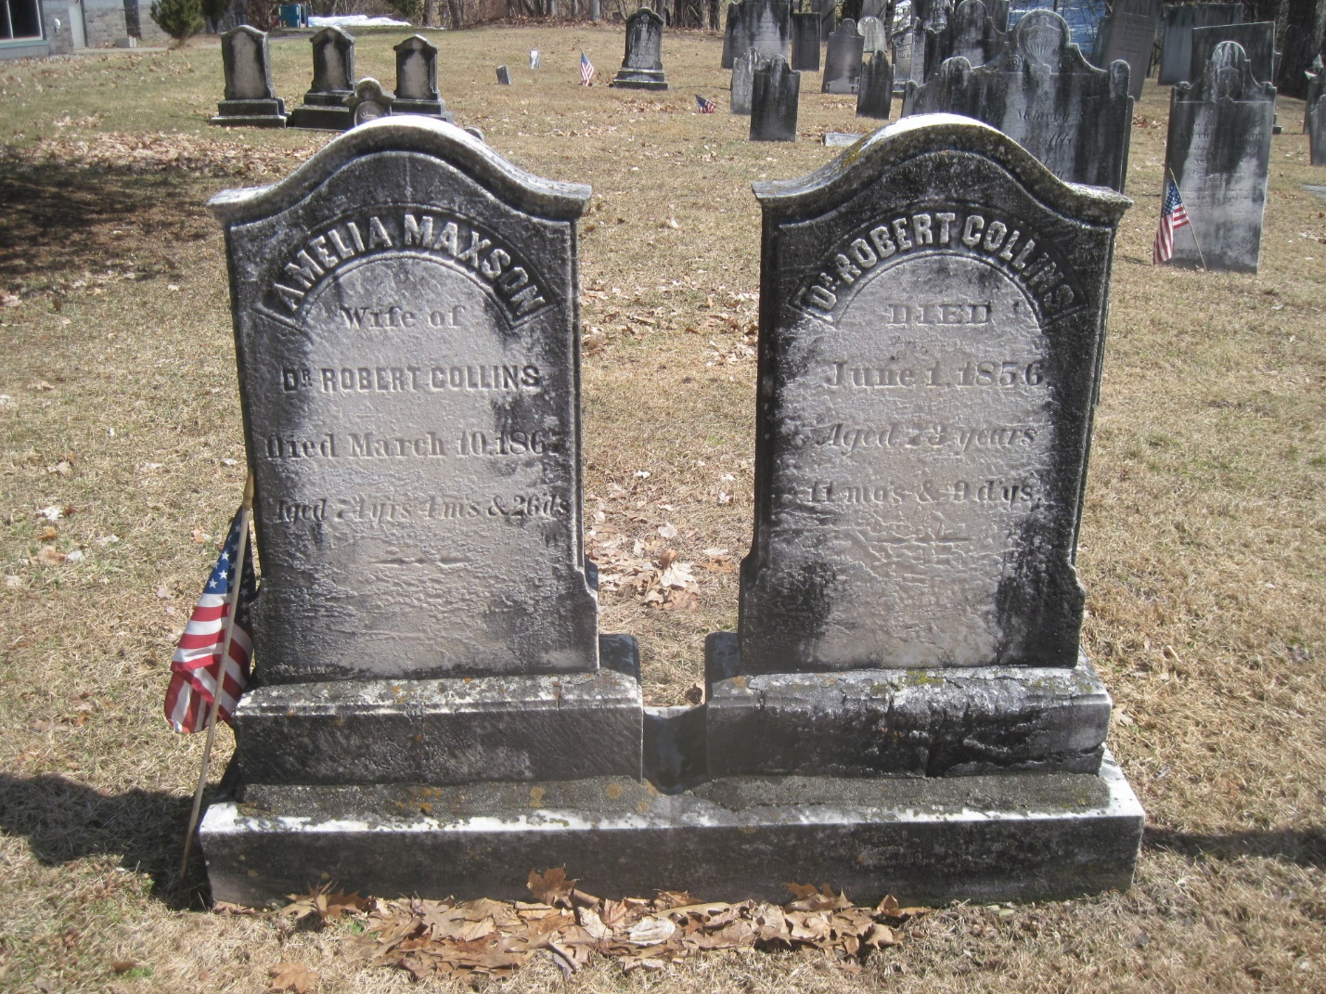
AMELIA MAXSON Dr. ROBERT COLLINS
Wife of Died
Dr. Robert Collins June 1, 1856
Died March 10, 1867 Aged 73 years
Aged 74 yrs 4ms & 26 ds 11 mos & 9 dys

White Church Cemetery
Brunswick, Rensselaer Co, NY
White Church Cemetery
Brunswick
Rensselaer County

