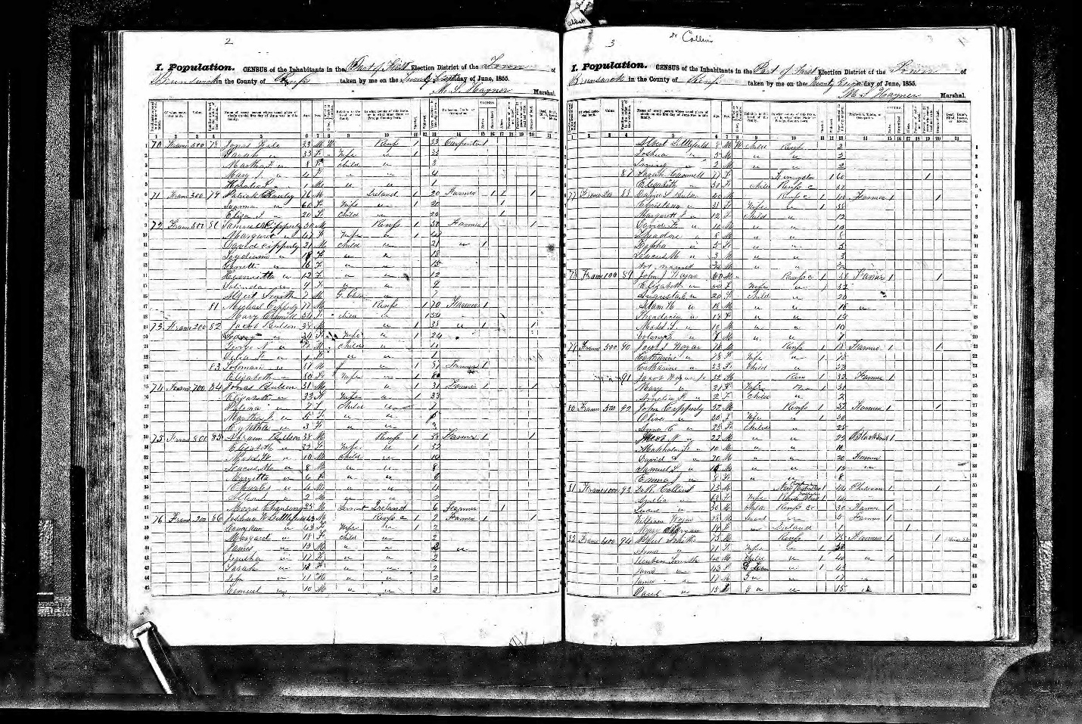

Dr. R. Collins 73 M Rockingham, New Hampshire Physician
Amelia 63 F Wife Washington, Rhode Island

