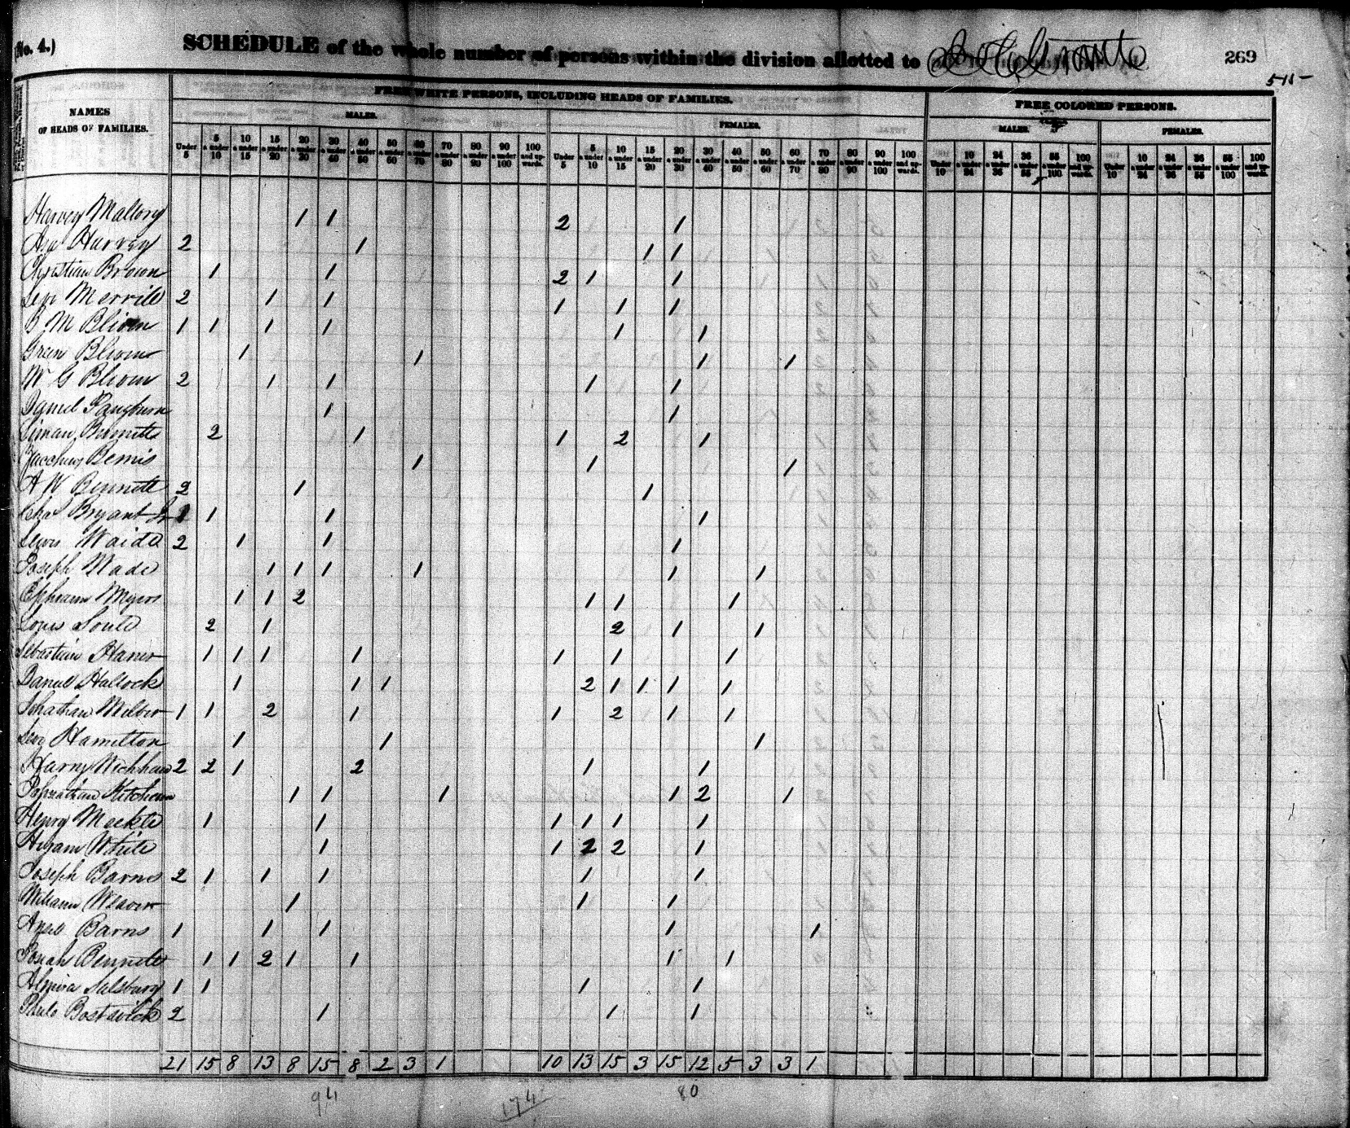
1840 Federal Census: Maryland, Otsego Co, NY

William Weaver: 1 Male aged 20 and under 30
?? 1 Female aged 5 and under 10
Alpha Houghton: 1 Female aged 20 and under 30

