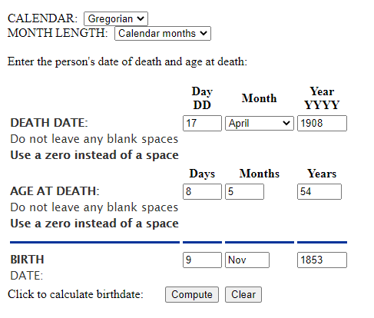

Based on age at death, Lucratia (Cramer) Weaver was born 9 November 1853

Death records provide best information available for birth, but it’s not always accurate.

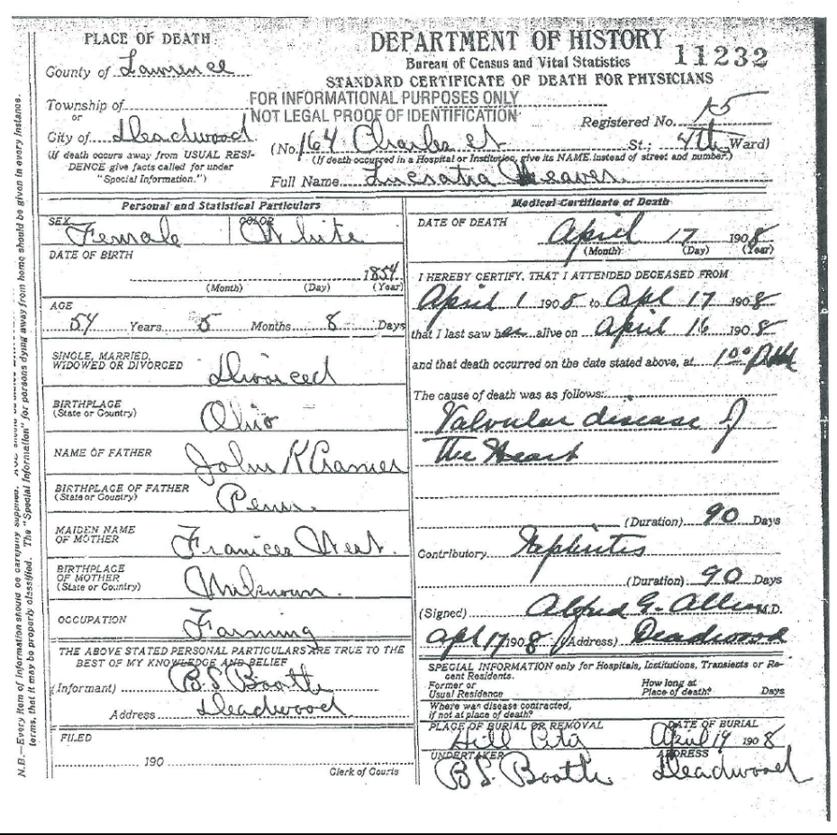

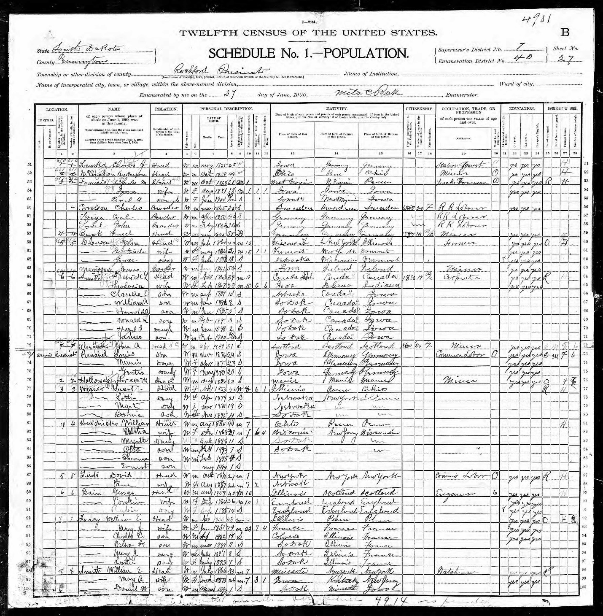
1900 Federal Census shows that Lucratia Weaver was born Nov 1853 in Illinois. Her marriage record states specifically that she was born in Illinois.

