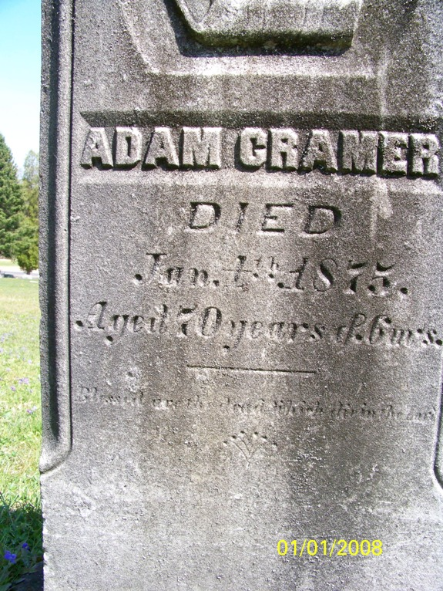

ADAM CRAMER
DIED
Jan. 4th 1875
Aged 70 years & 6 mos.
Cooperstown Cemetery
Cooperstown, Venango Co, PA

