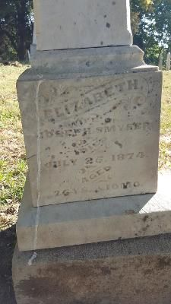
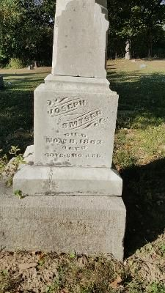
47126636 47126637
JOSEPH SMYSER ELIZABETH, wife of
Died Joseph Smyser
Nov 8, 1863 Died Aug 25, 1874

FRIENDSHIP METHODIST CHURCH CEMETERY
Trafalgar, Johnson County, IN

