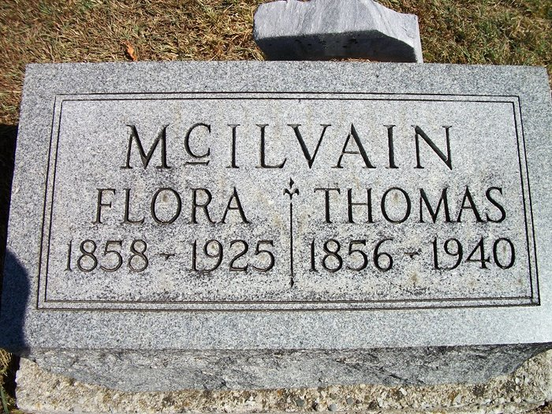

LICKINGSPRING BAPTIST CHURCH CEMETERY
Trafalgar, Johnson Co, IN

