Rose Sanders

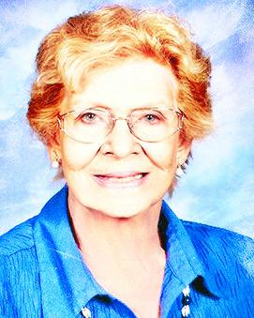
January 18, 1929 - May 29, 2015
Rose Mary Dierlam Keller Sanders has left this world for her next adventure. A sixth generation Texan and longtime resident of San Antonio, she was born on January 18, 1929 and departed on May 29, 2015 after a valiant 20-year battle with pulmonary fibrosis.
Rose Mary worked throughout her life to bring health and happiness to others. Her work at BAMC, Santa Rosa Hospital, the Medical Associates, as well as with various doctors in San Antonio brought her skills to many ailing citizens in the Alamo City. Upon retirement she volunteered with Methodist Hospital as a Bluebird. She also worked as one of the first Stephen Ministers in San Antonio to bring consolation to the needy.
Her lifelong passion for genealogy secured vital information for hundreds of people trying to discover their own lineage. Rose Mary was a member of the Society of Mayflower Descendants, Jamestowne Society, Daughters of the American Revolution, National Society Colonial Dames XVII Century, The Colonial Dames of America, Daughters of the Union Veterans of the Civil War 1861-1865, National Huguenot Society, National Society Ladies of the Thistle, Order of the Descendants of the Ancient Honorable Artillery Company and The National Society of the American Colonists.
Her husbands, Harold H. Keller and Joseph Sanders, preceded her in death. She is loved and missed by her sister, Nettie Williams, her brother, David Dierlam (and wife Sherry), her children, Eileen Keller and Annette Keller (and her husband Rodolfo Del Cid Fernandez), as well as her grandchildren; Leah Moss, Amanda Bendon, Rodolfo Del Cid Keller, Carlos Del Cid Keller (his life partner Danielle Lawrence) and Parke Benjamin, and her great-grandchild Jason Del Cid Lawrence.
She will always serve as a symbol of strength and resolve for her family and for all of those who were blessed with having her in their lives. Rose Mary is our mother, grandmother, healer, genealogist, amateur geologist, and avid archeologist wrapped around a kind heart. She will be sorely missed for her indomitable spirit, quick sense of humor, and passion for adventure.
Viewing is scheduled at Sunset Memorial Park (1701 Austin Highway, San Antonio, TX 78218) for Tuesday, June 2, 2015 at 7 p.m. An informal gathering and interment will be held at Sunset Memorial Park on Wednesday, June 3, 2015 at 8 a.m. with actual funeral services at the House of Prayer Lutheran Church (10226 Ironside Drive, San Antonio, TX 78230) at 10 a.m. followed by a community gathering in the hall of the church.
In lieu of flowers donations can be made in her name to the American Society for Clinical Pathology Scholarship Fund, P.O. Box 4286, Carol Stream, Illinois 60197-4286 (www.ascp.org).


Published in Express-News on June 1, 2015

