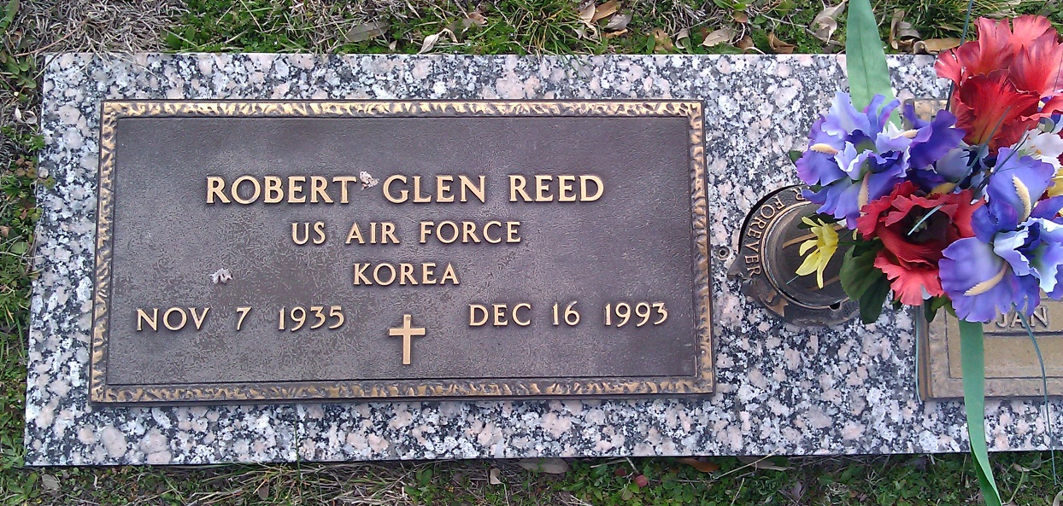

LAKEVIEW MEMORIAL PARK
Waxahachie, Ellis Co, TX

