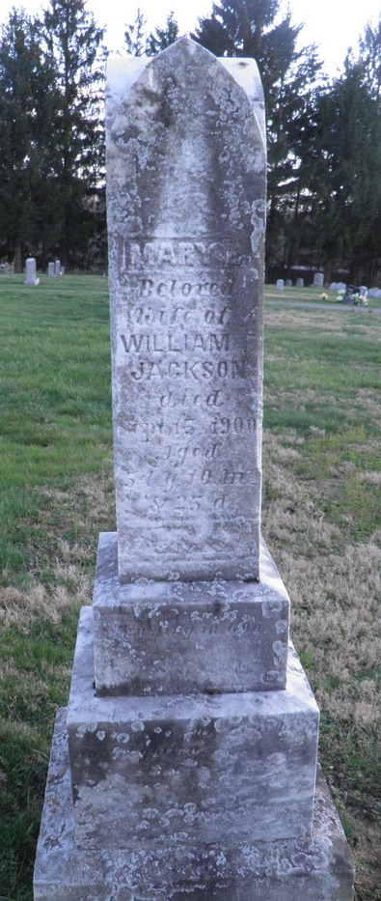
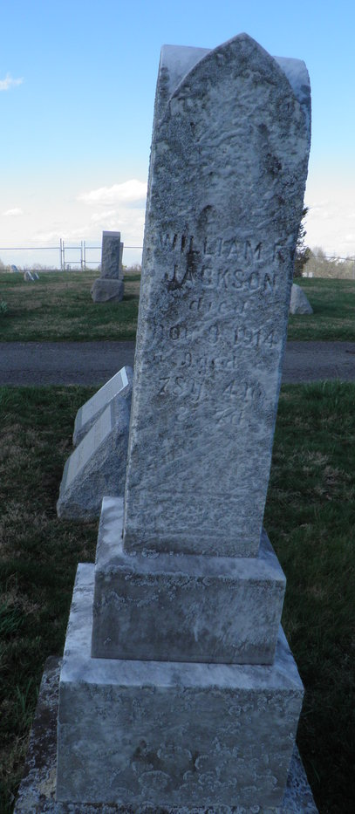
Pleasant Hill Cemetery
Morgantown
Monongalia County
West Virginia

