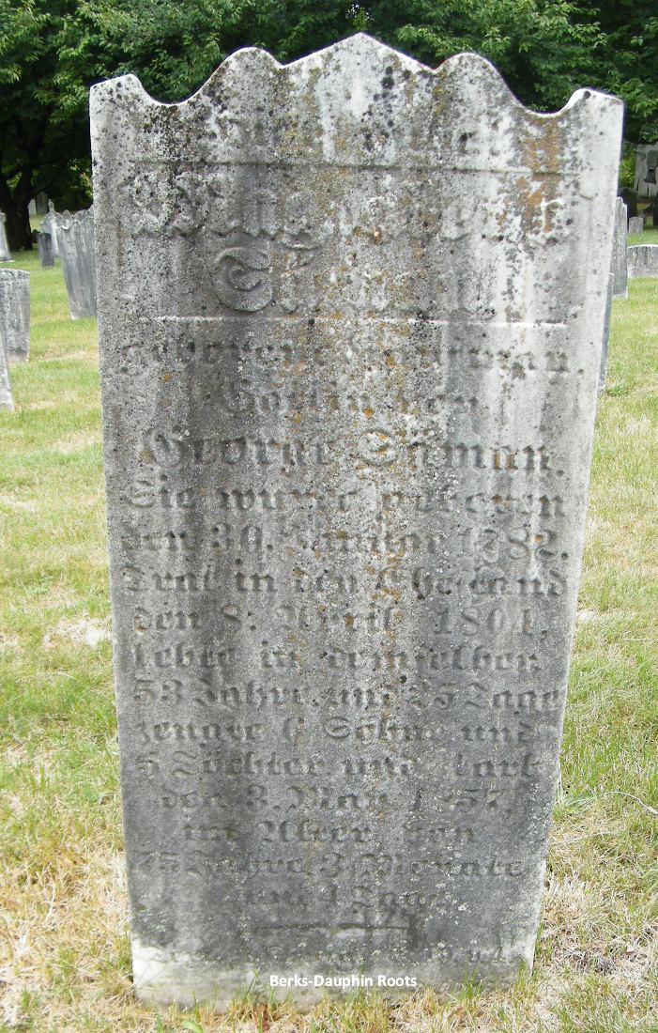

Madgalena Kauffman Seaman
Born 30 Jan 1782
Died 3 May 1857
Saint Michael’s Union Cemetery
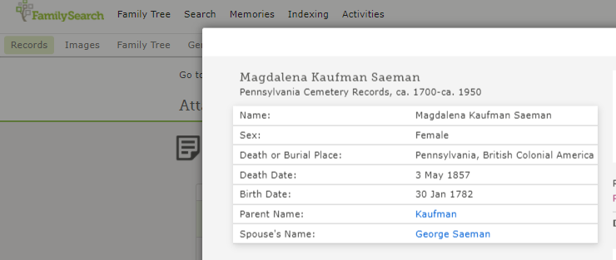
Tilden Township, Berks Co, PA

