RE: GEN 8 “Anna Seaman listed as the mother on Gen 7 Amenette Machemer Shuker death record…”
You are absolutely correct that “no records refer to this woman as Esther Anna, Esther A., Anne E., etc.”… because the informant for the death record made an error. At no time was the mother of Amenette / wife of Benneville Machemer ever named Anna/Anne. As we know, information on the death certificate is only as accurate as the informant can provide.
The attached 1850 census shows Benneville Machemer with wife Esther and four children. Amanda Machemer is shown as age 7, however her death certificate shows her birth as 1841, making her age 9 in 1850 and older than her sister “Emanetta” / Amenette.
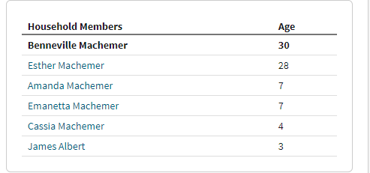

- Both Amanda (Machemer) Zimmerman’s obit and death certificate name her parents as Benneville Machemer and Hettie Seaman (see attached documents). The 1900 census for Hester (Seaman) Machemer (previously submitted), shows her living with Amanda Zimmerman (born 1841) and her husband, and Hettie Machemer is listed as mother-in-law.
- Death certificate for Catherine Machemer, listed on the 1850 census as “Cassia”, born 1845, show parents as Benneville Machemer and (no first name) Seaman – also attached.
- Death certificate for James Albert, previously submitted, names his parents as Benneville Machemer and Esther Seaman.

Gen 8: Benneville Machemer’s first and only wife and mother of Amanette (Machemer) Shuker was Esther / Hester / Hettie Seaman.

