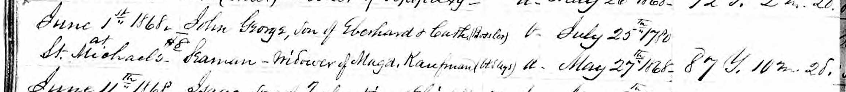
June 1st 1868 John George, son of Eberhard & Cath (Bossler) b. July 25th 1780
at #8
St. Michaels Seaman – widower of Magd. Kaufman ( ? ) d. May 27th 1868 87 y. 10 m. 2d.

