RE: Gen 9 – “the bulk of the information for generation 9 of your lineage comes from a 1911 family history.” This is incorrect.
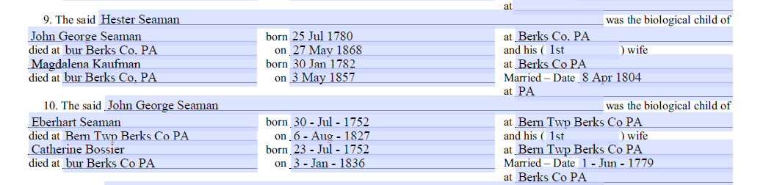

Previously submitted documents:
- B.D. Zweizig’s Private Pastoral Records, Evangelical Lutheran, Hamburg Reading PA – states that John George Seaman is son of Eberhard Seaman and Catherine Bossler; widower of Magdalena Kauffman; provides birth and death dates. Attached again.
- Gravestone for Johann Georg Seaman & translation: confirms birth and death dates, place of burial.
- Gravestone for Magdalena Kauffman Seaman: states wife of George Seaman, shows birth and death dates, place of burial.
- Pennsylvania Cemetery Records family search.org for Magdalena Kauffman “Saeman”: confirms birth and death dates.
- Death certificate for David Seaman: shows place of birth as Berks Co, PA for parents George Seaman and Magdalena Kauffman.

The ONLY additional information provided for Gen 9 that was taken from the 1911 History of the Seaman Family is their date of marriage.

