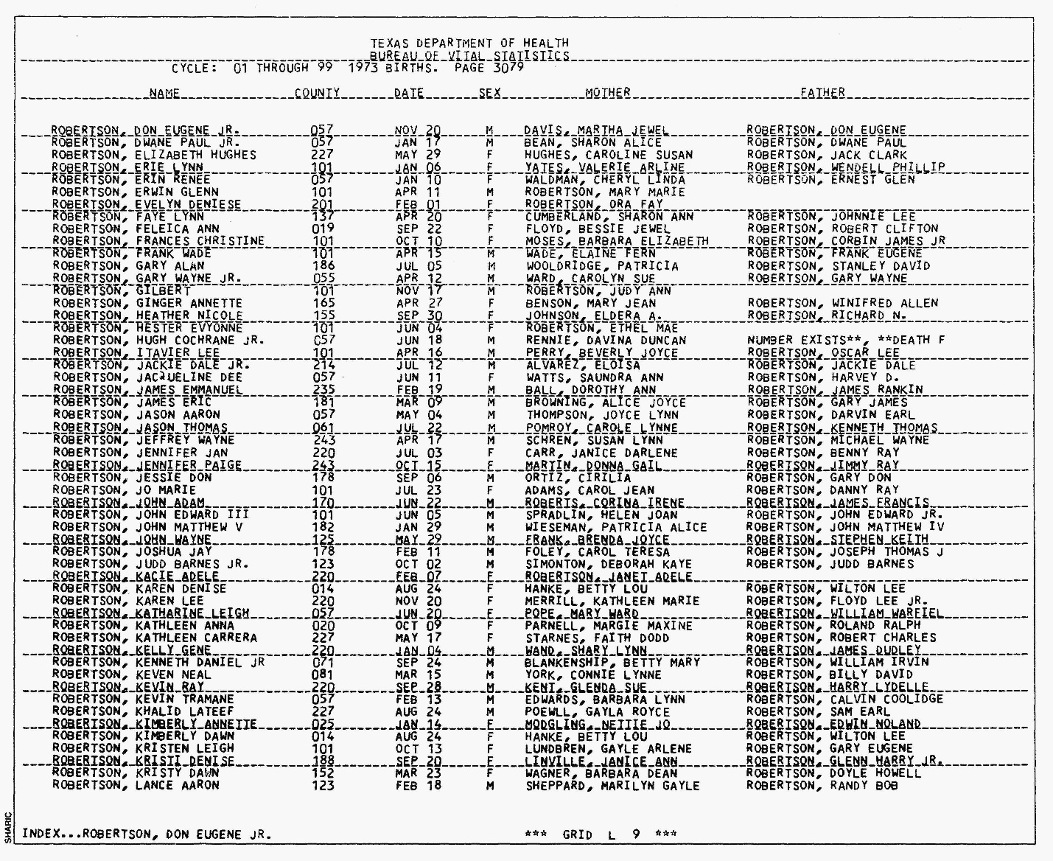

John Adam Robertson
Texas Birth Index
Name | John Adam Robertson
Event Type | Birth
Event Date | 22 Jun 1973
Event Place | Montgomery, Texas
Gender | Male
Father's Name | James Francis Robertson
Mother's Name | Corina Irene Roberts

