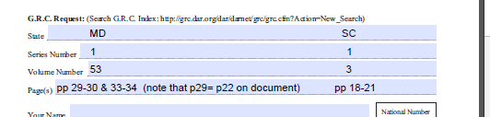
Below is what my chapter member ordered at my request so that it could be used for an application:

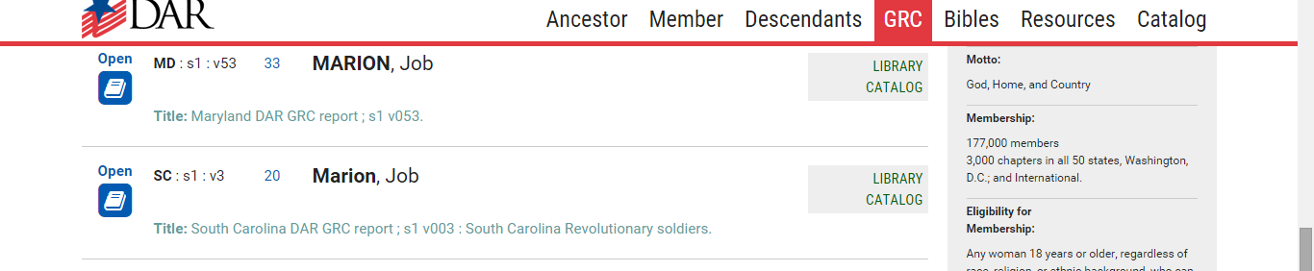
Here is the GRC listing on which that request was based:
Since I am registrar and have image access, I knew that the page doesn’t open to page 20 in the manuscript – it’s actually page 21:
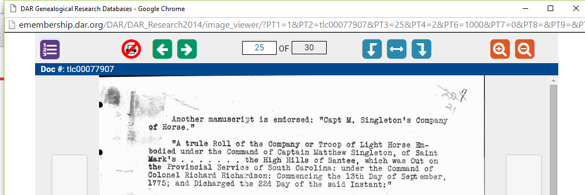

However, what she needed was actually on page 20:
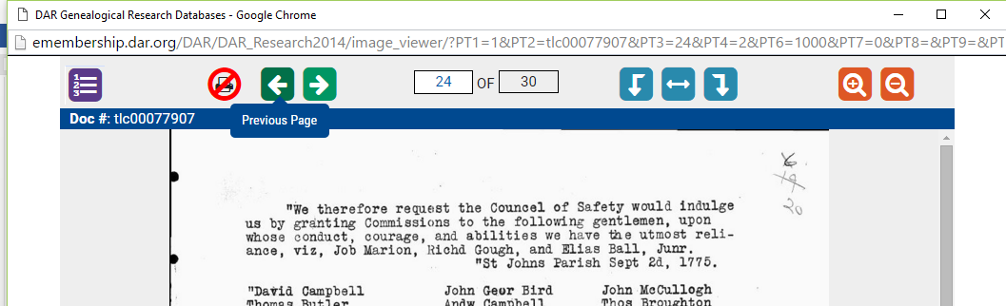

What you sent wasn’t based on the GRC listing or the actual page numbers. It was based something that we never could have guessed, so she received absolutely nothing of any value to her.

Please send from GRC SC s1 v3 – the actual pages 19 – 20 to:
Doris Franke
9238 Lasater St
San Antonio, TX 78254-2422

