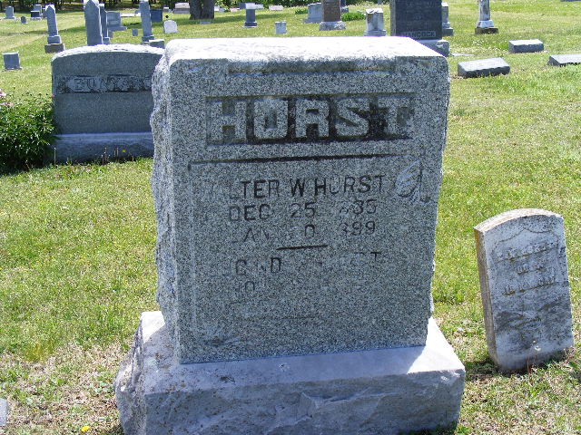

WALTER W. HURST
Dec. 25, 1835
Jan. 30, 1899

Greenwood Cemetery
Sedan
Chautauqua County, Kansas

