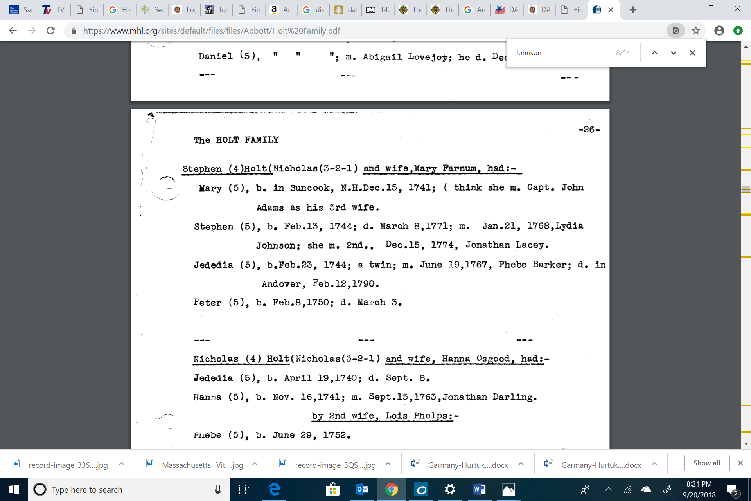

Lydia Johnson who married 1) Stephen Holt and 2) Jonathan Lary was born in 1746 – Mrs. Lydia Lary who died in 1818 was born in 1746
