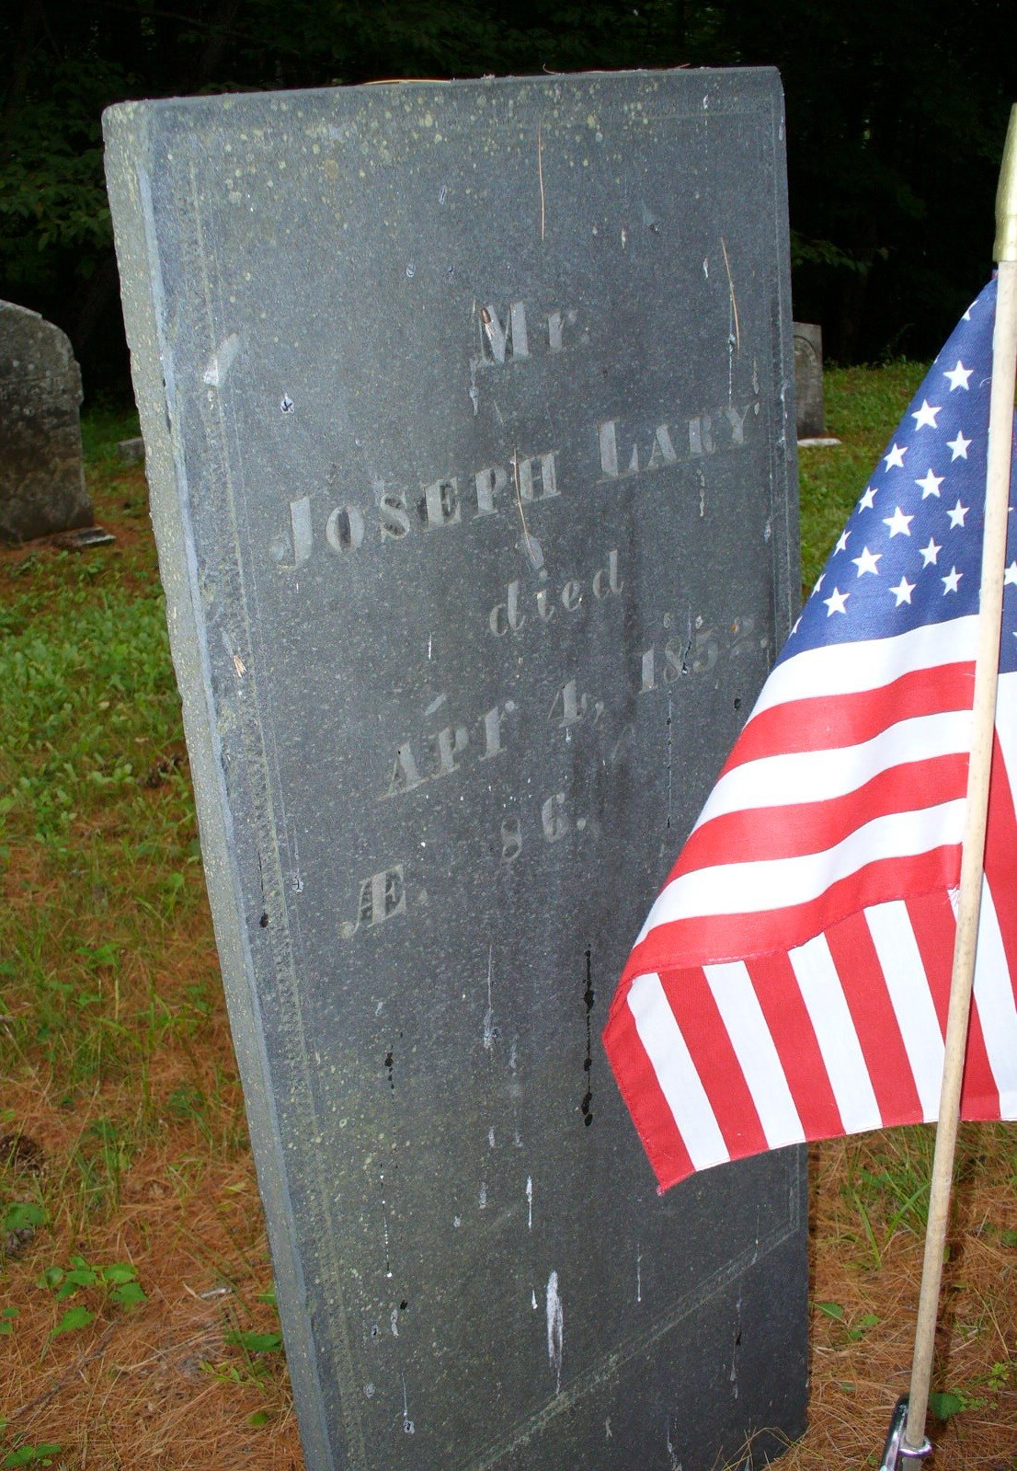

Mr. Joseph Lary
Died
Apr 4, 1852
AE 86

Lary Cemetery – Gilead, Oxford Co, ME

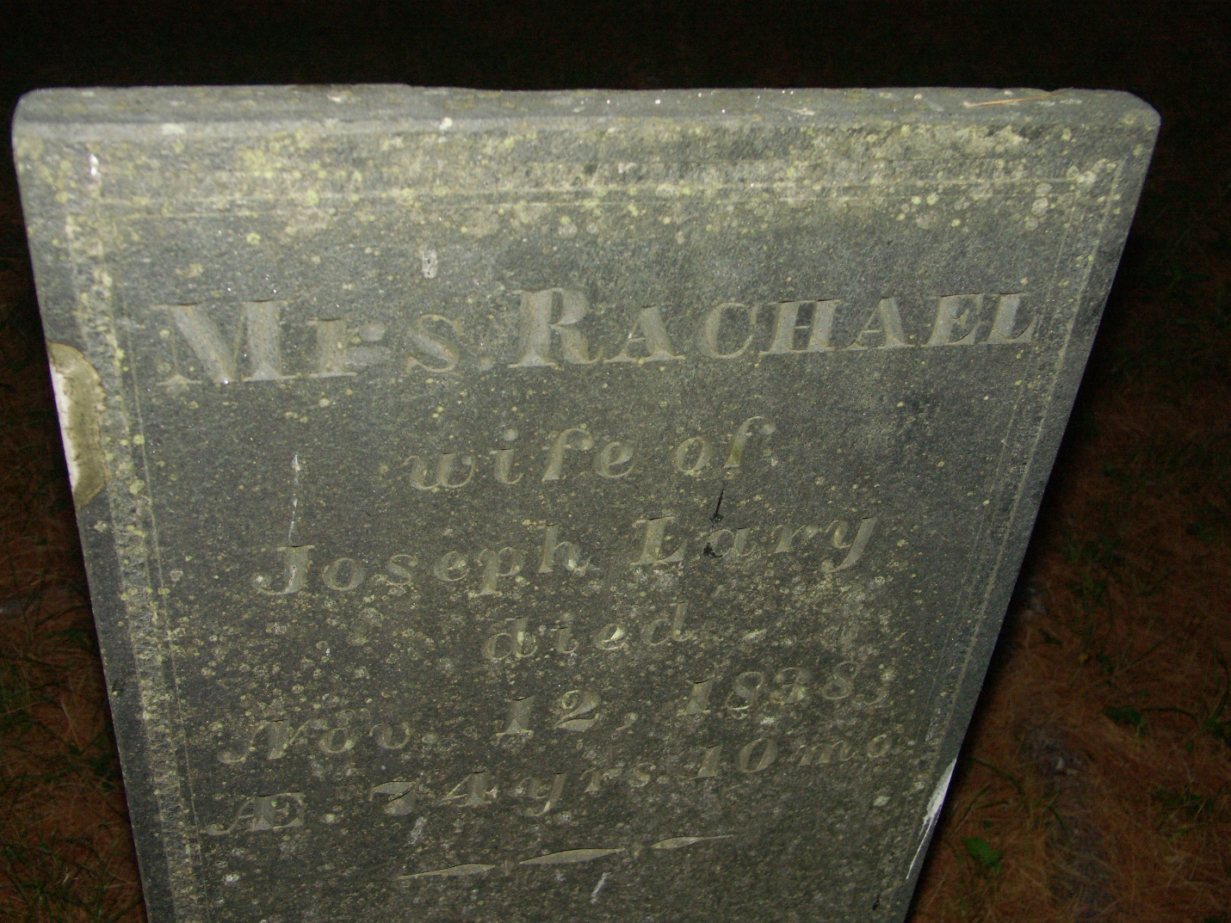

Mrs. Rachel
Wife of Joseph Lary
Died
Nov 12, 1838
AE 74 yrs 10 mo

Lary Cemetery – Gilead, Oxford Co, ME

