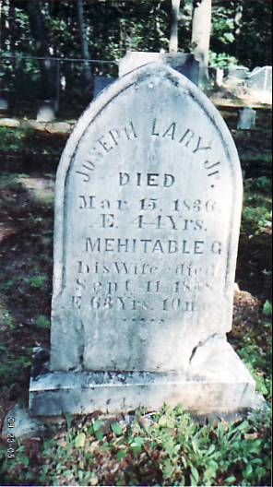

Lary Cemetery
Gilead, Oxford Co, ME

