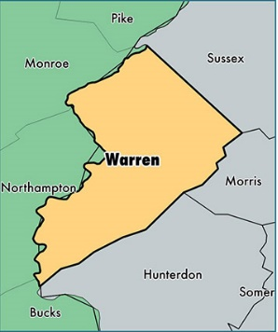
George Reiman (German spelling) / Ryman (anglicized spelling) / Riman
“George Ryman, the founder of this branch of the Ryman family in the United States, came about 1750, and settled near Easton, New Jersey…George married Kate Motley, and their children were: Peter..John; Jacob; Kate.”
“George Ryman…settled in New Jersey, near Easton, Pennsylvania…he had five children.”
There is no Easton, New Jersey, however Easton is a city in Northampton County, PA which borders Warren Co, New Jersey.,
“Peter Ryman, eldest son and child of George…was born in New Jersey in 1776. He removed near Hope, Warren county, New Jersey, and there his four eldest children were born.”
Additionally, church records have been found for:
- Catherine Raiman “dau of Juh Georg / Catherine born Mar 17 1773…married Juh Schneider…"
- Johan (John) George Rieman born 14 Jan 1784 recorded at Williams Twp, PA ,
Pennsylvania Archives gives service for Georg Ryman in Northampton County in 1782.
1790 Census lists George Riman living in Williams, Northampton County, PA
--------------------------------------------------------------------
This gives a timeline for George Reiman / Ryman / Riman:
Birth: a 1750
Marriage: c 1772
Birth of daughter Catherine / Kate: 1773 (she married 1793; died Northampton Co 1834)
Birth of son Peter: 1776 (he married 1799)
Revolutionary service from Northampton Co, PA: 1782
Birth of son John recorded in Williams, Northampton Co, PA: 1784
Living with family in Williams, Northampton Co, PA: 1790

Hayden, Hand & Jordan. Genealogical and Family History of The Wyoming and Lackawanna Valleys Pennsylvania. New York: The Lewis Publishing Co, 1906, p. 599
Smith, S. R. The Wyoming Valley in 1892. Wilkes-Barre, PA: The Scranton Republican, 1892, p. 99
City of Easton, PA. http://www.easton-pa.com/
http://www.worldatlas.com/na/us/nj/c-warren-county-new-jersey.html
Hayden, p. 599
St. John’s Lutheran Church, Easton, Northampton Co, PA, p. 161
St. Luke’s Old William Lutheran Church, Williams Township, Northampton Co, PA
Humphrey, John T. Pennsylvania Births Northampton County, Baltimore: Gateway Press, 1991 pp. iii, 173
Montgomery, Thomas Lynch. Pennsylvania Archives, Fifth Series, Volume VIII, Harrisburg, PA: Harrisburg Pub Co, 1906, pp 181-2.
1790 census Northampton Co PA, Williams, George Riman

