Re: Generation 4 – “no documentation was sent to prove that Charlotte Eugenia Moore in generation 5 is the daughter of George Gordon and Sallie Maude McCay in generation 6”. Please check your records again:
- Charlotte Eugenia Moore is Gen 4 (not Gen 5) on Eloise Hudson’s application.
- TX birth certificate is listed and checked as submitted for Gen 3 on her mother’s application.
- TX birth certificate #32766 and DAR Doc #4027702 (4 of 14) for Anc #A109285 Mem #847412 is shown online in supporting documentation and clearly lists parents for Charlotte Eugenia Moore as George Gordon Moore and Sallie Maud McCay.
Re: Generation 5 – George Gordon Moore – “None of the documentation sent specifically named George’s father as Gideon Ryman, but rather gave him the last name Moore on George’s DC. Charles’ information also gave his father’s last name as Moore, and he was not proven as brother of George.” They have the same mother, making them brothers.
1900 Federal Census from Cincinnati, Hamilton Co, OH shows “Charles N. Moore” as son of “Rose Ryman”, living in household of Catherine Moore; 1910 Federal Census also from Cincinnati, Hamilton Co, OH shows “Charles N. Ryman” living with “Rose Ryman” in the household of Catherine Moore.
Timeline:
1850: Gideon Ryman married Susan Greer. They had two legitimate sons: Robert born ca 1853 and James born 1855.
1878 / 1882: While married to Susan Greer, Gideon Ryman also had two illegitimate sons with Rose Brignole: George born 1878 and Charles born 1882. In the 1910 census, Charles N.’s name is given as the same as his mother, Rose Ryman.
1883: Gideon Ryman divorced Susan and married Rose Brignole in July 1883.
1885: Gideon and Rose Brignole Ryman had a legitimate daughter, also named Rose, born 1885 who died at age 9 months. Parents listed on death record and cemetery are “G. & Rose B. Ryman”. Since he was married to Rose Brignole at the time of this birth, he was willing to acknowledge her as his daughter.
1892: Gideon Ryman dies intestate, therefore leaving no will. Probate records (attached) show death in June 1892, next of kin named are George Ryman & Charles Ryman and “Rose Ryman guardian of George Ryman & Charles Ryman..heirs at law of Gideon Ryman deceased…”
All of Gideon Ryman’s legitimate children had predeceased him: Robert died in 1888, James in 1881, and infant Rose in 1886. However, all five of Gideon Ryman’s children, as well as Gideon and Rose (Brignole) Ryman are buried in the same cemetery – Spring Grove Cemetery in Cincinnati, Ohio: http://www.springgrove.org/geneology-search.aspx
George and Charles, sons of Rose Brignole and Gideon Ryman, were illegitimate and took the last name of the family with whom they and their mother were living: Moore.
The fact still remains that, whatever their name, they were biologically descended from Gideon Ryman and the attached probate records prove that line of descent.

RE: Generation 6 – “no documentation that mentioned Rose as Gideon’s wife gave her maiden name…” Attached cemetery record for burial of Rose Ryman shows:
- “Parent’s Names Joseph & Mary Gordon Brignole”
- “Wife of Gideon Ryman”

RE: Generation 8 – “prove Mary’s place of birth as NJ…” Her residence and birth in New Jersey is shown by:
- Genealogy of the Swasey Family shows will of Barnabas Sweezey, leaving a portion of his 800 acres of land in the township of Hope, Warren County, N.J. to his son William, whose “dau..Mary, m. Peter Ryman at Hope.” (Attached)
RE: Generation 8 – Peter as son of George Reiman
There are three secondary sources for this information, each printed in a different state, but all of which provide the same information:
- Hayden, Rev. Horace. Genealogical and Family History of The Wyoming and Lackawanna Valleys, New York: Lewis Publishing Company, 1906, pp 599-600. (Previously submitted)
- Smith, S. R. The Wyoming Valley in 1892. Wilkes-Barre, PA: The Scranton Republican Print, 1892, pp 98-99. (Previously submitted)
- Bradsby, H.C. History of Luzerne County, Pennsylvania. Chicago: S.B. Nelson & Co, 1893, p. 1312. Attached - NOTE: Biography of William Penn Ryman was written during his lifetime.
There is a fourth source that provides critical support for the above because it is written by William Penn Ryman, great-grandson of George Reiman/Ryman and gives contemporary information about his grandfather Peter Ryman:
- Ryman, William Penn. The Early Settlement of Dallas Township, Luzerne County, Pennsylvania. Wilkes-Barre, PA: 1901, pp 3-4, 27, 38, 41. (Attached)
Genealogy involves research, documentation, and as importantly, logic. William Penn Ryman would have personal family knowledge from his father, Abram concerning his grandfather Peter and his great-grandfather, George Reiman/Ryman. His published historical work shows that he supported his personal knowledge with research and it provides significant contemporary information that supports the secondary sources.
- Early Settlement of Dallas Township P 27: “Peter [Ryman] spoke with a decided German accent.”
Linguistic studies show that an adult who speaks with a pronounced accent would have learned English as a second language as an adult and, therefore, Peter Ryman would have grown up in a primarily German-speaking environment and spoken only German when growing up.
From Western Washington University’s Center for Instructional Innovation and Assessment: “During childhood, language acquisition is a natural consequence of prolonged exposure to a language….Any small child will acquire native fluency in any language if exposed to it on a consistent basis in a social setting. A child will naturally acquire native fluency in more than one language under these circumstances. In the overwhelming majority of individuals, however, this natural ability to acquire spoken language without deliberate effort begins to diminish sharply at about the age of puberty (12-14 years of age). Teenagers exposed to a new language after this age will acquire it with …a deliberate, painstaking, intellectual process that rarely, if ever, results in the total native fluency acquired so naturally by any small child, regardless of intellectual ability or personal motivation. The deficiency is particularly evident at the phonetic level, and adults who learn second languages usually speak them with some recognizable non-native accent. http://pandora.cii.wwu.edu/vajda/ling201/test4materials/secondlangacquisition.htm
WHY IS THIS IMPORTANT? Published sources and personal family knowledge provided by William Penn Ryman show that Peter Ryman was son of German immigrant George Reiman/Ryman. Both linguistic studies would logically show that a man with a “decided German accent” grew up in a German-speaking community.

RE: Generation 9 – “George Reiman in generation 9 was living in New Jersey and moved to PA prior to the Revolution is needed, since Peter in generation 8 gets married in New Jersey in 1799”.
- There is absolutely no primary source to show that George Reiman ever lived in New Jersey. The primary source shows Peter living in New Jersey.
- All of the primary sources show George Reiman/Ryman living in Pennsylvania.
- All of the secondary sources say George Reiman / Riman / Ryman “came to America in 1750 settled in New Jersey, near Easton, Pennsylvania”.
However, the attached article from the Historical Society of Pennsylvania states that “Between 1727 and 1775, approximately 65,000 Germans landed in Philadelphia and settled in the region while some German immigrants landed in other ports and moved to Pennsylvania. The largest wave of German immigration to Pennsylvania occurred during the years 1749-1754…By the time of the Revolutionary War, there were approximately 65,000 to 75,000 ethnically German residents in Pennsylvania.”
A logical conclusion is that George Reiman/Ryman, who arrived in American in 1750, would have come with this wave of German immigration and. It’s clear from all the documentation (military service, baptism of his son, tax records, and census records) that he lived near Easton, Pennsylvania and logically it is far more likely that he lived on the Pennsylvania side rather than settling in New Jersey.
CONCLUSION: “Peter [Ryman] spoke with a decided German accent.” Logic and documentation concerning linguistic patterns, along with German immigration patterns, would clearly imply that Peter was born and lived his early years in the German-speaking communities in Pennsylvania. I would, therefore, conclude that George Reiman came to Pennsylvania in 1750, settled in the German community, and further, I would amend Peter Ryman’s birthplace to simply “near Easton, PA”, most likely Northampton Co, since all of his father’s documentation places him there near the time of Peter’s birth. Since Peter Ryman moved from New Jersey to Dallas Co, PA, I propose that an incorrect assumption was made that he was born in New Jersey, however no research shows that to be true.
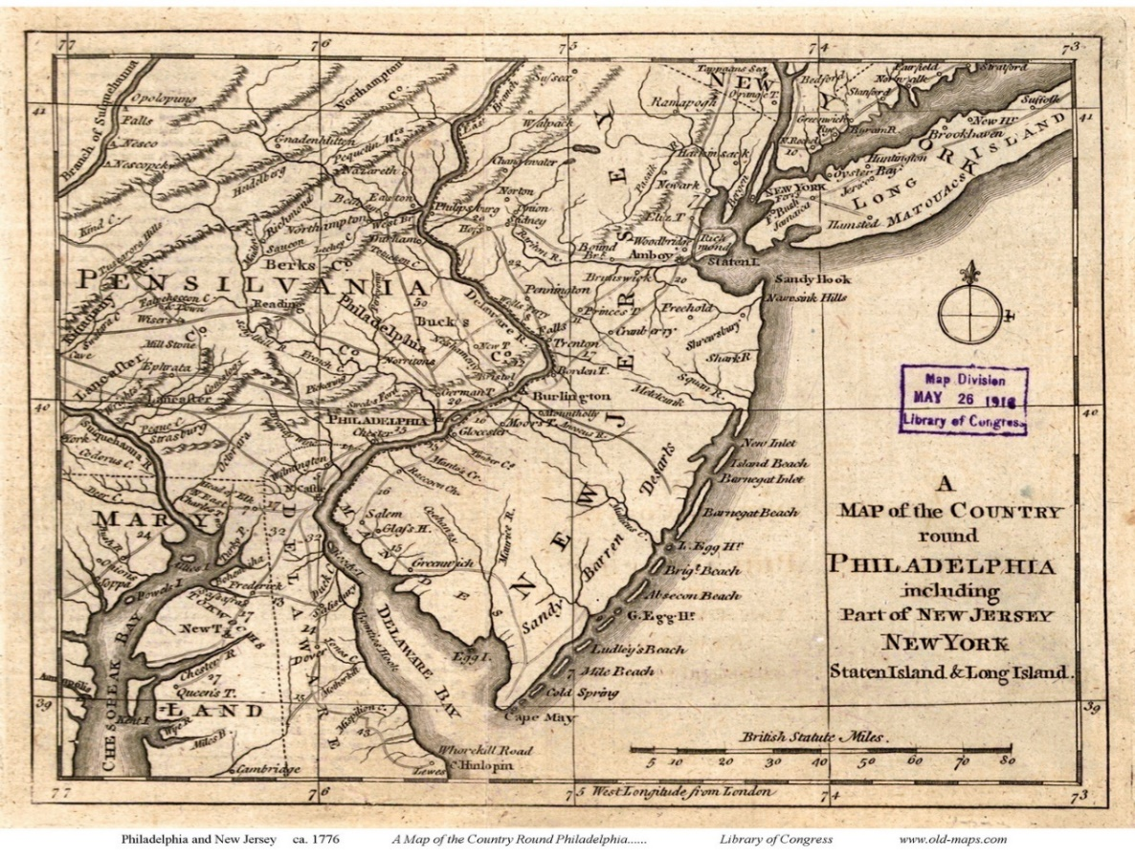
This map, dated ca 1776, shows clearly that Easton, PA was one of the only settled towns in the area and on the border between Pennsylvania and New Jersey. Easton, PA and Phillipsburg, NJ are only about 2 miles apart.

Movement between Pennsylvania and New Jersey would have been extremely likely.
Unlike a woman, who customarily remains with her parents until marriage, a man who is of marriageable age and able to support himself and his family, isn’t necessarily living with his parents at the time of his marriage. We know that Peter 1) married in New Jersey (proven by his marriage record); 2) moved from Warren County, New Jersey in 1814 (stated by his grandson, William Penn Ryman in The Early Settlement of Dallas Township p. 41); however his “decided German accent” shows he learned English as a second language during his adult years.
Conclusion: Peter Ryman grew up in Pennsylvania among the German-speaking community who immigrated there. As an adult, he would have been in contact with the English-speaking communities in New Jersey and had the opportunity to learn English as a second language. It is logical to conclude that he was born in Pennsylvania and moved to New Jersey as an older teen or adult prior to moving back to Pennsylvania in 1814.

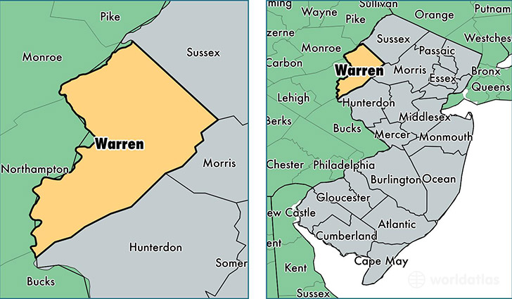

All of the primary sources support the secondary sources. Research into linguistic patterns clearly show that Peter Ryman grew up in a German-speaking community. We know through immigration patterns that there was a large German migration into Pennsylvania about 1750, the same time that his father, George Reiman/Ryman, came from Prussia (now part of Germany) and it is logical to conclude that George settled in Pennsylvania and that Peter Ryman grew up there. Every primary source shows residence for George Reiman/Ryman in Northampton or Bucks Co, Pennsylvania, which is consistent with the German immigration pattern. Settlers to Luzerne Co, PA came from Warren County, NJ and the map above shows that Warren County is an adjoining county to both Bucks and Northampton counties.
Every source shows Peter Ryman as son of George Ryman.
Every primary source shows George Reiman/Ryman as living in Pennsylvania and research into German immigration supports that conclusion.

RE: Generation 7 – “proof that Joseph Ryman in generation 7 who was born in NJ and is enumerated in the 1850 census in Franklin Co IN is the son of Peter Ryman and Mary Swesey in generation 8 who died in PA.”
- 1850 census in Franklin Co IN shows Peter Ryman born in NJ and wife Elizabeth born in PA.
- Wife Elizabeth was daughter of Nathaniel Worden as was previously submitted. “Nathaniel Worden..was a taxable inhabitant of..Luzerne county….children: Elizabeth, married Joseph Ryman..died in Indiana, July, 1866.” Hayden, Horace Edwin. Genealogical and Family History of The Wyoming and Lackawanna Valleys Pennsylvania. New York: The Lewis Publishing Company, 1906 p. 536. Shows move from Luzerne County, PA to Indiana.
- 1820 census in Dallas, Luzerne Co, PA proves Nathaniel Worden’s residence there.
- “Uncle Peter Ryman…and..his son, Joseph Ryman..” Ryman, William Penn. The Early Settlement of Dallas Township, Luzerne County, Pennsylvania. Wilkes-Barre, PA: 1901, p27. Shows relationship between Peter Ryman of Dallas, Luzerne Co, PA to son Joseph.
- Will of Peter Ryman (submitted previously) names son Joseph.

