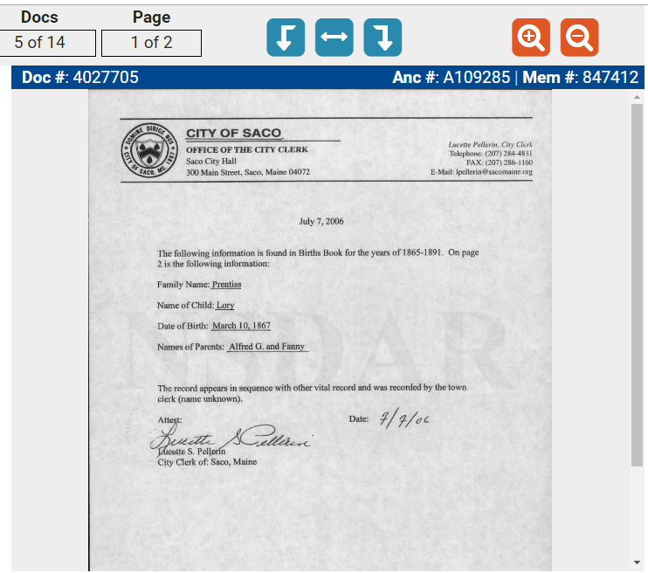
Birth record for Generation 5 Lory Prentiss was previously submitted by applicant’s mother:

Birth record for Generation 5 Lory Prentiss was previously submitted by applicant’s mother, to which application this is attached.

Birth record for Generation 5 Lory Prentiss was previously submitted by applicant’s mother:

