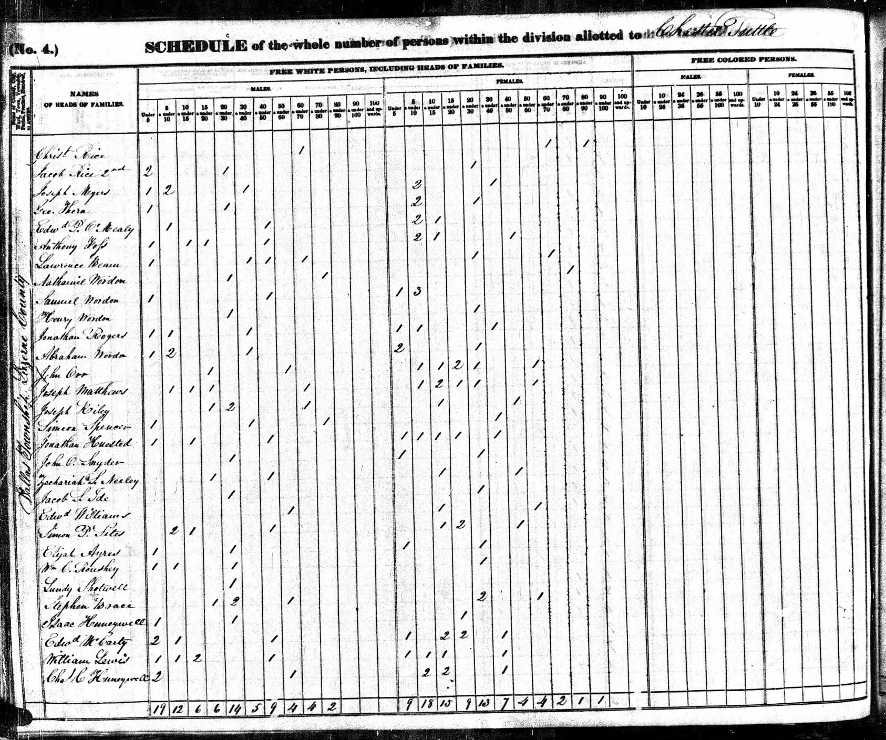
1840 Federal Census
Dallas Township, Luzerne Co, PA

