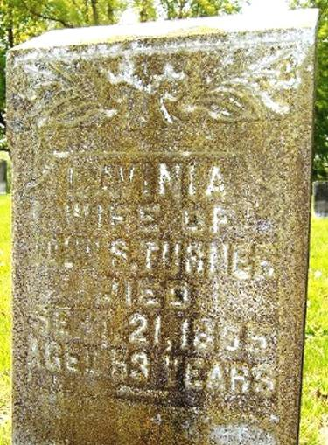

LAVINIA
WIFE OF
JOHN S. TURNER
DIED
SEPT 21, 1865
AGED 53 YEARS

Buried
Cabarrus Co, North Carolina

