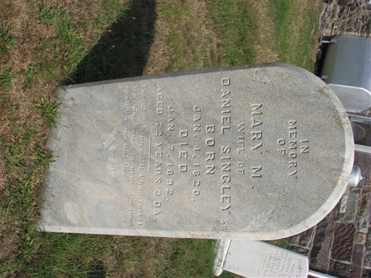
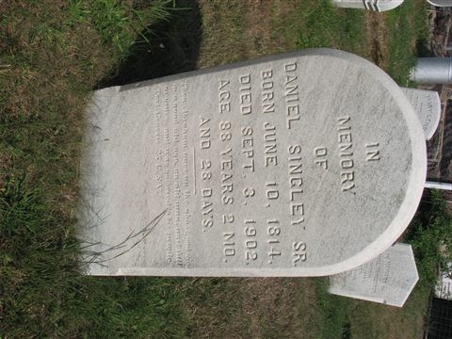
Burial: Hargers Union Cemetery; Beaver Valley, Columbia Co, PA
The Bloomsburg Daily, date: Sept 11, 1902, Page 3
DEATH OF DANIEL SINGLEY
Daniel Singley, one of the most prominent and highly respected citizens of Beaver township, died at his home about two miles east of Shumantown on Wednesday, September 3, aged eighty-eight years, two months and twenty-three days, death resulting from a general breaking down of the system incident to old age. About two years ago he suffered a light stroke of paralysis, which slightly affected his mind at times, but otherwise was in a fairly good state of health, although for some time past he has been too feeble to travel about without assistance. The illness, however, which culminated in his death was of but short duration, he having been confined to his bed only about four days.
Mr. Singley, who was the youngest of a family of fifteen children, was born in Mifflin township before Beaver township was carved out of it. He was the son of Jacob Singley and was the last surviving member of the old stock of Singley's, his brother Lawrence having died in Schuylkill county about five years ago at the age of ninety-seven years.
Mr. Singley's last visit to the county seat was ten years ago last spring, but during the earlier years of his life was a frequent visitor to Bloomsburg, where he was well and favorably known to the older residents. His memory used to revert to the time when Bloomsburg was still in its infancy and when it was commonly spoken of as Eyertown. For sixty-two years Mr. Singley resided on the farm on which he died.
Deceased is survived by seven children, four sons and three daughters, his wife having preceded him to the grave about ten years ago. The children are Joseph, Henry and Levi, of Beaver township, Daniel L and Mrs. Simon Johnson of Schuylkill county and Mrs. CharlesTritt and Mrs. Charles Klingaman, of Beaver township.
Funeral services were conducted at his late home on Saturday last at ten o'clock, Rev. O. F. Dry, of Mifflinville, officiating. Interment was made in Harger's cemetery in Beaver township.
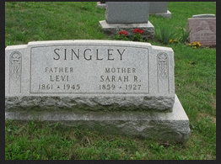

Burial:
Hargers Union Cemetery
Beaver Valley
Columbia County
Pennsylvania, USA

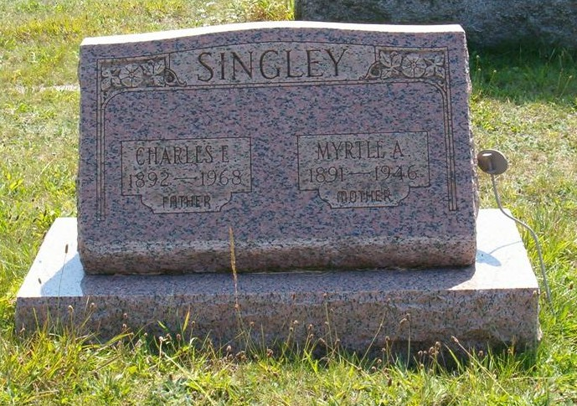

Myrtle Adora Rice
Wife of Charles E. Singley.

Notes for DANIEL SINGLEY:
http://familytreemaker.genealogy.com/users/s/i/n/Wilbur-J-Singley-jr/GENE1-0008.html
Daniel was the youngest son of Jacob Singley and Catherine Klotz.
Daniel and Mary had 4 children, the two youngest were alive in 1940.
Daniel was 88 years old when he died.
The following was copied from the Singley Genealogy (Revised 1965), page 61:
Biography of Third Generation Daniel Singley
Daniel Singley, born June 10, 1814, was the youngest of fifteen children born to Jacob and Catharina Klotz Singley. He lived his entire life on the same farm on which he was born, and died there on September 3, 1902.
This farm was acquired by his parents in 1802 and is located about three miles east of Harger's Church or two miles east of Shumantown. The highway now designated as Route 44 passed through the upper portion of this farm of 100 acres. The original farm as such did not remain the same, for in 1885 the northern portion of 40 acres was sold to the youngest daughter, Mary, and her husband, Charles Klingaman. The latter family farmed this portion until 1903 when they moved to Berwick.
At the time Jacob Singley settled this farm it was a part of Northumberland County. However, upon the organization of Columbia County in 1813, this farm and to a point six or seven miles east thereof became a part of the new Columbia County. The farm buildings of the Klingaman farm are close to Route 44, well below the level of the road, and on the left going west toward Bloomsburg. The buildings on the original farm can be seen from a point on the road about one-half mile east of those on the Klingaman farm and are directly south of those on the Klingaman farm.
Since, Daniel Singley, son of Jacob, was born there, lived there more than 88 years and died there, it might be inferred that he never got very far. This is true as far as physical displacement is concerned; but he did get to church regularly and lived a wholesome Christian life and so did his family. He was highly respected by his neighbors and revered and honored by his family.
Daniel Singley married Mary Magdelene Lehr about 1839 or 1840 At that time his father Jacob (born Sept. 22, 1761) was in his late seventies and undoubtedly had been ably assisted by Daniel and possibly one or more of Daniel's brothers. There is no record at hand indicating when his brothers and sisters removed from the farm. However, upon the death of Jacob Singley in 1844 the farm apparently became the property of Daniel Singley, who continued to own it (except for the 40 acres sold to Charles and Mary Klingaman) until his death on Sept. 3, 1902 at the age of 88 years and nearly 3 months. The mother, Catharina Klotz Singley, continued to live with Daniel and his family until her death in 1853. The mother was born Christmas Eve 1768. Thus it will be seen that Daniel Singley came from hardy stock, the parents averaging 83½ years at death at a time when life expectancies were much less than at present.
Both of Daniel's parents are buried at Harger's Church with the graves beautifully marked with the original tombstones to which has now been added an appropriate marker and flag support in commemoration of Jacob Singley's service in the Revolutionary War,
Daniel Singley and his wife, Mary M., were the parents of eight children, all of whom were born amd reared on this original farm. All of these children are, of course, now deceased. The names, dates of birth and death, married names of the girls, and place of burial follow:
Joseph 1842-1912 Harger's
Catharine 1844-1931 Mt Zion (Mrs. Simon P. Johnson).
Henry 1848~1904 Harger's
Daniel 1850-1927 Harger's
Sarah 1852-1872 Harger's
Rebecca 1853-1937 Harger's (Mrs Charles Tritt):
Mary 1858-1955 Rose Lawn, Berwick (Mrs. Charles Klingaman)
Levi 1861-1945 Harger's
It is interesting to note the attained ages of these children of Daniel Singley. Sarah died of fever in her 20th year. Henry became a paralytic at age 21, but lived to 56 years old. The other six all had life spans above average; the attained ages to nearest year being 70, 77, 80, 86 and 97 years.
It is also interesting to note the number of Biblical names. Bible names in the past were more common than at present, but in this family the number was rather unusual. The grandfather was Jacob, the father Daniel married Mary Magdelene Lehr and the children were Joseph, Daniel, Sarah, Rebecca, Mary and Levi. Also Kate married Simon Peter Johnson, and Rebecca had children Nathaniel, Adam and Eva, more commonly called Eve.
Another rather unusual fact is that Jacob was born in 1761 and his grandson Levi was born in 1861, not a record but not many cases of this kind will be found.
A farm boy from birth, the older Daniel took charge of the farm following the death of his father and operated it as owner with the help of his sons for nearly sixty years.
Daniel Singley, the father, was severely handicapped by rheumatism and arthritis but Joe, Henry, Dan and finally Levi were of great help to him. Born 1814, he was almost 47 years old when the Civil War began Henry was only 13, Dan 11 and Levi was not yet born. Joe was 19 years old and subject to draft. It was necessary for him to remain on the farm and do practically all of the field work to provide a living for the family of ten. As was customary in cases of this kind a substitute was provided at an expense of $300 to go to war. Many, many times have I heard my mother Mary tell of the joy and jubilation, as well as the special day of prayer, when the substitute returned unscathed and in excellent health.
The farm was operated in this manner for the duration of the war and probably for some few years thereafter. Some time later Joe married and acquired a farm near Harger's Church where he lived the remainder of his life. Dan also married and lived at numerous places, the last years being spent in Forty Fort [PA]. Kate, too, was married and later lived many years near the Mt. Zion cross-roads, the farm being plainly visible from Mt. Zion Church. Still later she lived in Ringtown and finally, upon the death of her husband Simon Peter Johnson, she lived in Reading until her death during Holy Week of 1931.
Rebecca was married to Charles Tritt about 1880 and moved elsewhere. My mother, Mary, was married to Charles Klingaman on March 15, 1881, and after residing with John Klingaman and wife on a large farm they returned to the old homestead for several years and occupied the old house, a newer dwelling having been built some time before. About 1885 they took possession of the upper 40 acres.
Thus, in the late 1880's the residents of the original farm were my grandparents, Daniel and Mary Lehr Singley, Henry who was paralyzed in 1869, and Levi and his wife, Sarah Enterline Singley, with their growing family.
Mary Magdelene Lehr Singley, wife of Daniel Singley, died in 1892. Daniel continued to live with Levi and family for another 10 years until his death in his 89th year on Sept. 3, 1902. The farm now became Henry's property. Henry died less than two years later and thereafter Levi and his family became the sole occupants and owners.
After most of Levi's children had reached adulthood and left home the farm was sold. Thus this farm had been in the same family for about 110 years. Only several years ago both sections of the original farm were again owned by one individual.
Daniel's father, Jacob, was born Sept. 22, 1761, and Daniel died Sept, 3, 1902, just 19 days before the 141st anniversary of the birth of his father. Many times I heard my mother, Mary, mention this fact and usually added "I wonder if I can do that." Her death occurred on June 10, 1955, on exactly the 141st anniversary of the birth of her father Daniel.
Daniel Singley and his wife had many grandchildren, the youngest of whom was born less than one month after Daniel's death. Of these grandchildren probably half survive. Of the six sons and daughters who had families of their own there are survivors in every family except that of Kate, whose daughter died within the past year. Records of these families should be obtained from these survivors.
Written in 1962 by
Foster E. Klingaman
This biography of Daniel Singley, b. 1814 was copied essentially without editing.

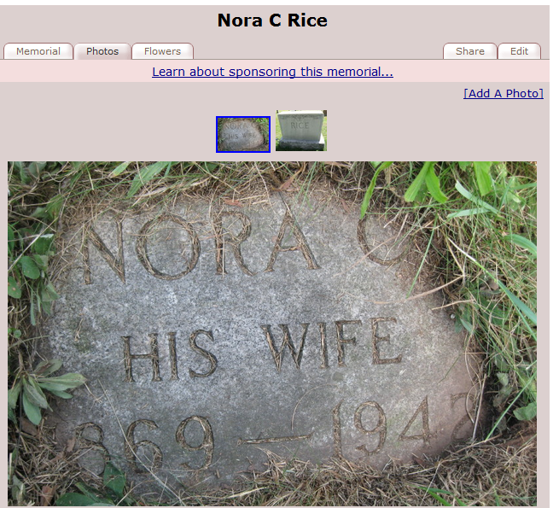
Parents of Myrtle Adora Rice who married Charles Singley

