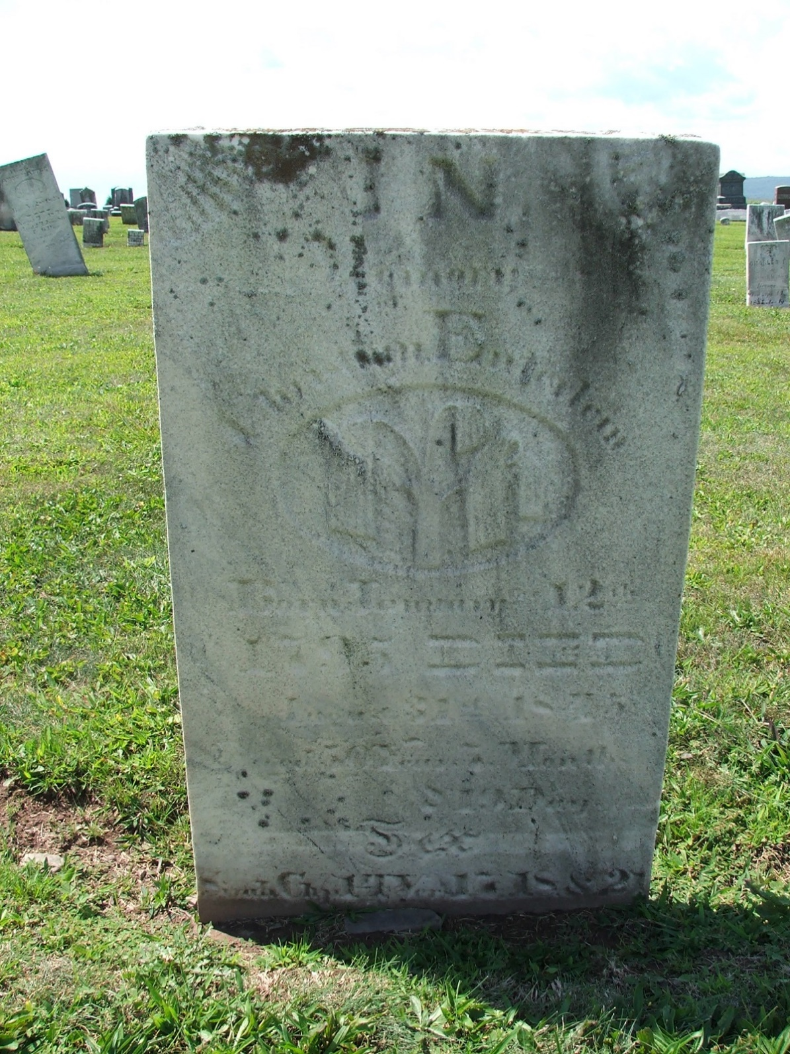

CHRISTIAN ENTERLINE

Born January 12th 1795
Died August 31st 1845

Simeon United Lutheran Church Cemetery
Gratz, Dauphin Co, PA

