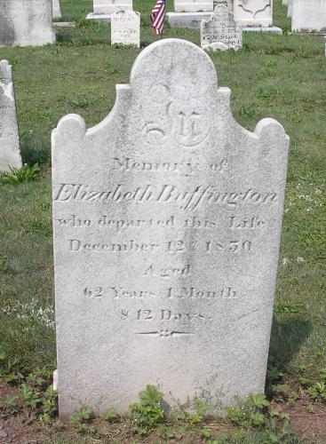

In
Memory of
Elizabeth Buffington
Who departed this Life
December 12, 1850
Aged
82 Years 1 Month
& 12 Days

Simeon United Lutheran Church Cemetery
Gratz
Dauphin County, Pennsylvania
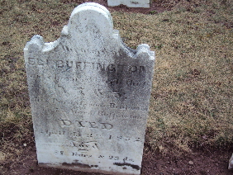

Eli Buffington
Died
April the 3rd 1852

Simeon United Lutheran Church Cemetery
Gratz
Dauphin County, Pennsylvania

