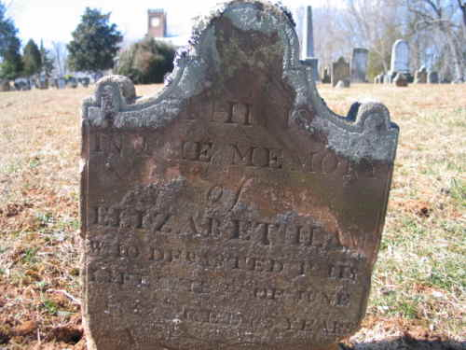

ESTEP?????? Elizabeth Lane
22 Jun 1839
Burial:
Falling Spring Presbyterian Church Cemetery
Glasgow
Rockbridge County
Virginia, USA
Plot: E-2

1 April 1839
Floyd Co, KY

