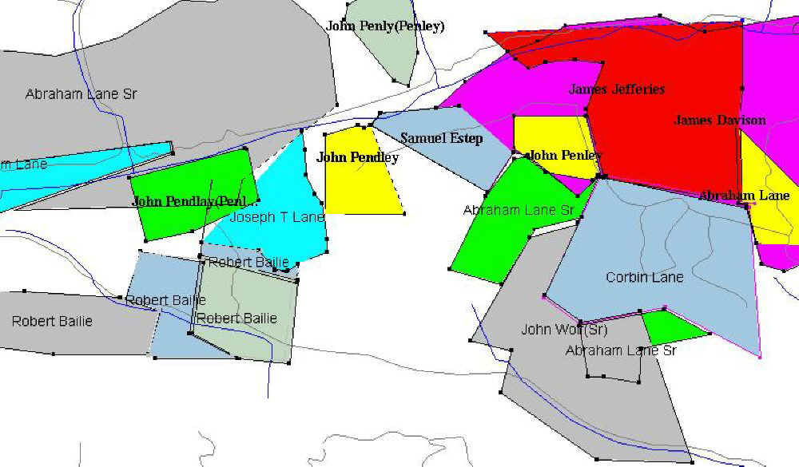

http://www.rootsweb.ancestry.com/~vaschs2/corbinlane-2.htm
CORBIN LANE
Patriot, Pioneer, Patriarch
Corbin Lane was born about 1735-42, probably near Baltimore, MD, and was one of eleven children of Samuel and Jane (Corbin) Lane. His birth date is uncertain, but he was on a tax list near Baltimore in 1763. He was the grandson of Rev. Dutton and Pretitia (Tydings) Lane and Edwin and Mary Jane (Wilkerson) Corbin. His grandfather, Dutton Lane was a Quaker minister who became a Quaker after marrying into the Tydings family. His great-grandfather was Col Samuel Lane, one of the early leaders of Maryland.
Very little is known about Corbin's life before coming to the Northeast Tennessee (then North Carolina) and southwest Virginia area in 1779-81. His father, Samuel Lane, had numerous land transactions in Maryland and the family was apparently prosperous, but no will or family Bible has been found to prove the family members. Biographies of two of Corbin's brothers, Rev Samuel Lane, Jr, of Pennsylvania, and Lambert Lane, of Kentucky, have provided some clues of the family.
Corbin's parents apparently spent several years in England in the early 1740's because Lambert and Richard were said to have been born there. Lambert was said to have married in 1760 while "living in the wild country among the Indians" on the Susquehanna River, and there is one reference that Samuel Lane bought land there after selling several tracts near Baltimore about 1755. These stories suggest that Corbin may have spent several years of his youth in a wilderness area around the Susquehanna River and may explain the pioneering nature of the family. There are some indications that Corbin was educated because he signed his deeds in Greene Co, NC (now TN) and was involved in activities suggesting at least a moderate education.
Corbin's first known public record was his appearance on a tax list in Baltimore Co, MD in 1763. Also present on the list were Samuel Lane Sr and Samuel Lane Jr. The next listing was in 1773 on a tax list in Bedford Co, PA, with his brothers Dutton and Samuel Jr. They were also at the same location in 1779, but the next appearance of Corbin's name was on a tax list in Washington Co, NC/Tenn in 1781 and when he purchased 250 acres of land in Lee Co, VA (now Scott Co) on Feb 18, 1782.
Corbin Lane served the Revolutionary War in Sullivan Co and Washington Co, North Carolina (now Tennessee) by providing supplies and services in 1782 and 1783 as proven by two pay vouchers, No. 279 dated 6/26/1782 and No. 1391 dated 6/12/1783. The details of his Revolutionary War services are not known; DAR research has caused them to list him as a Patriot, but not (yet) as a soldier as some other references has indicated. It is probable that he participated in militia campaigns against the Indians that were aiding the British in the war. There is no evidence that Corbin or Dutton Lane participated in the battle of King's Mountain on Oct 7, 1780, so he likely arrived in the northeast Tennessee and southwest Virginia area after that date. Ten Lanes were in the battle.
It is probable that Corbin and his brother Dutton came to Washington Co and/or Greene Co, North Carolina (now Tennessee) together about 1780-81. They likely traveled with other Maryland families that moved about that time (notably, the Esteps and Lovells) and may have spent some time in modern day North Carolina before coming to this area. They followed their brother Lambert Lane who apparently came to the area in the early 1770's and their first cousins Tidence Lane and John Fuller Lane who also came in the early 1770's from the Yadkin River area of North Carolina. Tidence and John Fuller Lane were close friends of William Bean, usually considered to be Tennessee's first permanent settler in 1769. They had been neighbors in Pittsylvania Co, Virginia and were neighbors near present day Gray, Tennessee; there is some suggestion that they were also neighbors in Maryland prior to the move to Pittsylvania Co, VA, in 1746. One researcher has also suggested that William Bean's wife was a Lane, but no substantial evidence has been found. Tidence Lane was the first preacher of a permanent church in Tennessee, founding the Buffalo Ridge Baptist Church at Gray about 1777. There is no indication that Corbin and Dutton Lane had a close association with Tidence and John Fuller Lane, but they would have obviously had some contact and would have been influenced by them. Tidence was born in Maryland in 1724, and was thus several years older than Corbin and Dutton.
Corbin Lane likely lived on the 250 acres in Red Hill that he bought in 1782 until about 1786 when he got a land grant in Greene Co, NC/TN. Abraham Lane was born January 18, 1783 in Russell Co, VA (now Scott Co) according to his death record in Scott Co, VA. But all censuses report place his birthplace in Tennessee. All evidence points to the death record being correct, but Abraham would have identified to spending his youth in Greene Co where the family lived 1786-1795. It is likely that the family had to leave Virginia in 1786 because of the Indian attacks in southwest Virginia at that time. As soon as it was safe to return to Virginia, the family did so in 1795, and they returned to the same 250 acres at Red Hill that Corbin had purchased in 1782.
Evidence indicates that Corbin Lane and his family lived the rest of his life on the 250 acre farm in the present day Red Hill community north of Gate City, Virginia. The southern border of the farm is about where the present-day road passes the Benton and Vineyard Cemeteries and one corner was near the present day Red Hill Methodist Church. This farm was on one of the better farm sites in Scott Co, and is generally good land. The exact home site on the farm has not been identified, but it probably was at the springs in the valley and the same as where Abraham built a log house in 1820 that was said to be one of the largest log houses in the area; that house burned in 1943.
The exact location of the home in Greene Co has not been determined, but it was probably on Lick Creek between Greeneville and modern-day Baileyton. Corbin probably lived in Greene Co before buying land in Virginia; he sold 150 acres on Lick Creek on January 14, 1783. Corbin bought and sold at least five tracts of land in Greene Co. While in Greene Co, he was named by court records on four occasions as part of groups to build roads; on one occasion, he was named as the overseer of the project.
There are few public records of Corbin Lane between 1795 and his death in 1816. He has been thought to have been a land dealer because of his activity in Greene Co, but few deeds have actually been found in Lee, Russell or Washington Cos. In 1814, he was exempted from paying county taxes on account of his age and bodily infirmities, and he was also exempted from paying county poor rates and public tax for an aged infirmed slave called Cuff. He signed the petition to form Scott Co in 1814. An aged slave woman named Cuff was also named in Corbin's will in 1816, but there is no other information about her.
Corbin's wife was Frances "Fanny" Prock (or Brock, Frock or Proctor). Her last name is from tradition since no public records of their marriage or her parents has been found. We can speculate that she and Corbin married in Pennsylvania or Maryland prior to moving to Tennessee and Virginia; if she was from Pennsylvania or Maryland, her name was likely Proctor since there were several well-known Proctor families in the area. William Proctor was a judge in Bedford Co, PA in the 1770s. Another possibility is that Frances was living in North Carolina and they married after Corbin moved. Her first name appears on the death record of Abraham Lane, and she testified in the Wolfe vs. Wolfe court case in Wytheville, VA. No record of Frances has been found after Corbin's death except for the court testimony. She likely would have lived with one of her children, or she may have died shortly after Corbin. Most people think that Frances was Corbin's second wife because of the gap of several years in the children's birth dates between the early 1770s and 1778. Corbin and Dutton were probably both widowed in Pennsylvania, then remarried in the late 1770s and came to the area together. Dutton's first wife was named Mary, and his second was Kezia. Kezia died at the age of 100 in Scott Co in 1850, and her birthplace was given as Pennsylvania.
Corbin named only two sons, Abraham and Samuel, in his will and that has been frustrating to researchers for many years, since he was thought to have had at least ten children. They were as follows:
1. Elizabeth Lane, (b. abt 1765/70 - d. bef 1820), married Shadrach Estep. She is a possible daughter. She had 9 children, including a son Corbin Estep.
2. Thomas Lane, (b. abt 1770 - d. 1792?), no information.
3. Mary Susan Lane, (b. 1771 - d. 1820/29), married Samuel Estep in Greene Co. They had 9 children.
4. Rachel Lane, (b. 1778/80), married Asa Pennington in Lee Co, VA, and lived in TN, KY and IND. They had 7 children.
5. Abraham Lane, (b. 1/18/1783 - d. 2/28/1869), married Catherine Wolfe, lived in Scott Co, VA. They had 14 children.
6. Samuel Lane, (b. 1784 - d. 1818/20), married Mary Speer, lived in Scott Co, VA. They had 4 children.
7. Frances Lane, (b. 1780/90 - d. aft 1830), married John Williams, lived in Scott Co, VA. She had no children.
8. Rebecca Lane, (b. 1788 - d. 1850/53), married John Penley, lived in Wayne Co, KY. They had 10 children.
9. Ruth Lane, (b. 1790 - d. aft 1850), married Thomas Spears, lived in Floyd Co, KY. They had 10 children.
10. Temperance Lane, (b. 1793/95 - d. aft 1860), married James Williams, lived in Scott Co, VA. They had 10 children.
There is a possibility that Catherine (b. 1778 in PA - d. 1855 in Scott Co) who married John Peters was a Lane and another daughter of Corbin Lane. Tradition in some branches of the family is that she was a Lane and John's second wife. If she could be proven to be a daughter of Corbin and Frances Lane, that would also prove that Corbin and Frances married in PA and that Frances was likely a daughter of William Proctor.
The first three of Corbin's children were probably born of his first wife. Only Abraham, Samuel and Mary are proven children, but there are very strong evidences that the others were his children. There are legends that also suggest that William Lane and Benjamin Lane were Corbin's sons, but circumstantial evidence indicates that they were Dutton's sons. Records on the frontier during the late 1700's and early 1800's are very limited, but we keep hoping that a conclusive document will be discovered soon to prove all of his children. The search is also made difficult by the large number of Lanes in this area in the early years.
We of Abraham Lane's family are very fortunate that our lineage to Corbin Lane is solidly proven, and anyone who has an interest in joining the Daughters of the American Revolution (DAR) or the Sons of the American Revolution (SAR) can do so. So far, I have identified about 30,000 descendants of Corbin Lane. But there probably are more than 50,000 descendants and maybe as many as 100,000.
Donald W. Lane

