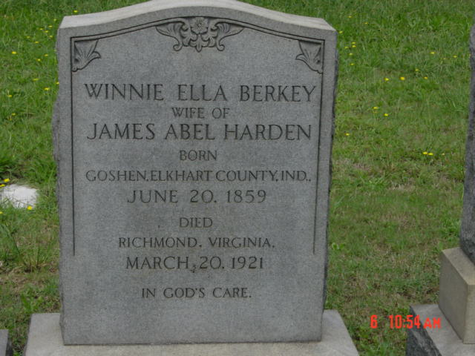

Shockoe Hill Cemetery
Richmond, VA

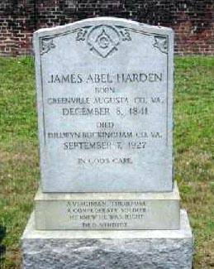

Shockoe Hill Cemetery
Richmond, VA

