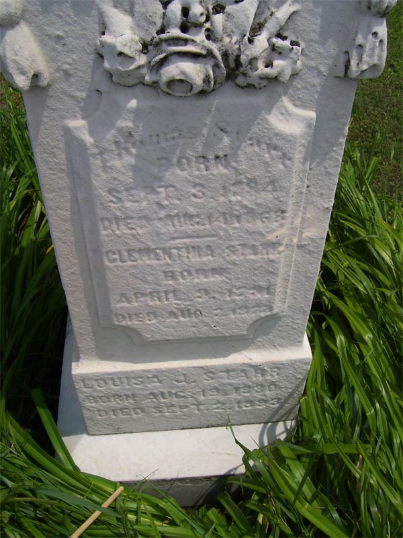

Thomas Starr
Born
Sept. 3, 1784
Died Aug. 14, 1868
------------------
Clementina Starr
Born
April 9, 1791
Died Aug. 7, 1873

Rochester Station Cemetery
Rochester
Lorain County, Ohio

