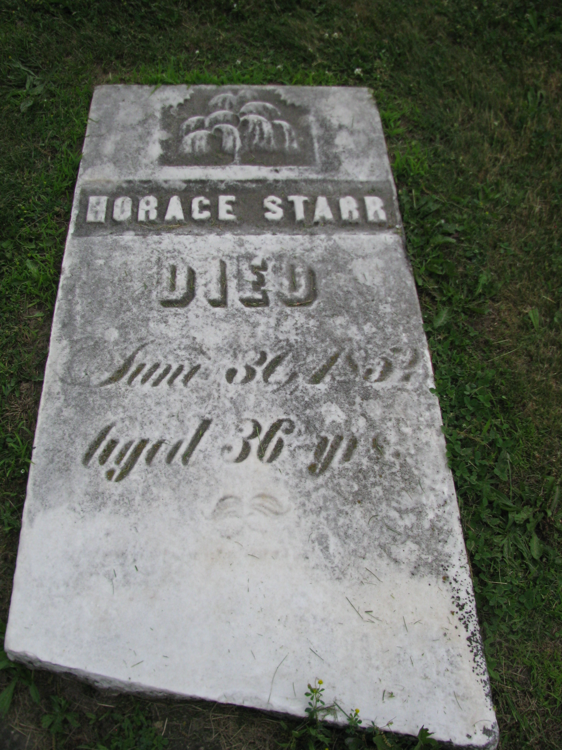
South Murray Ridge Cemetery
Elyria
Lorain County, Ohio

