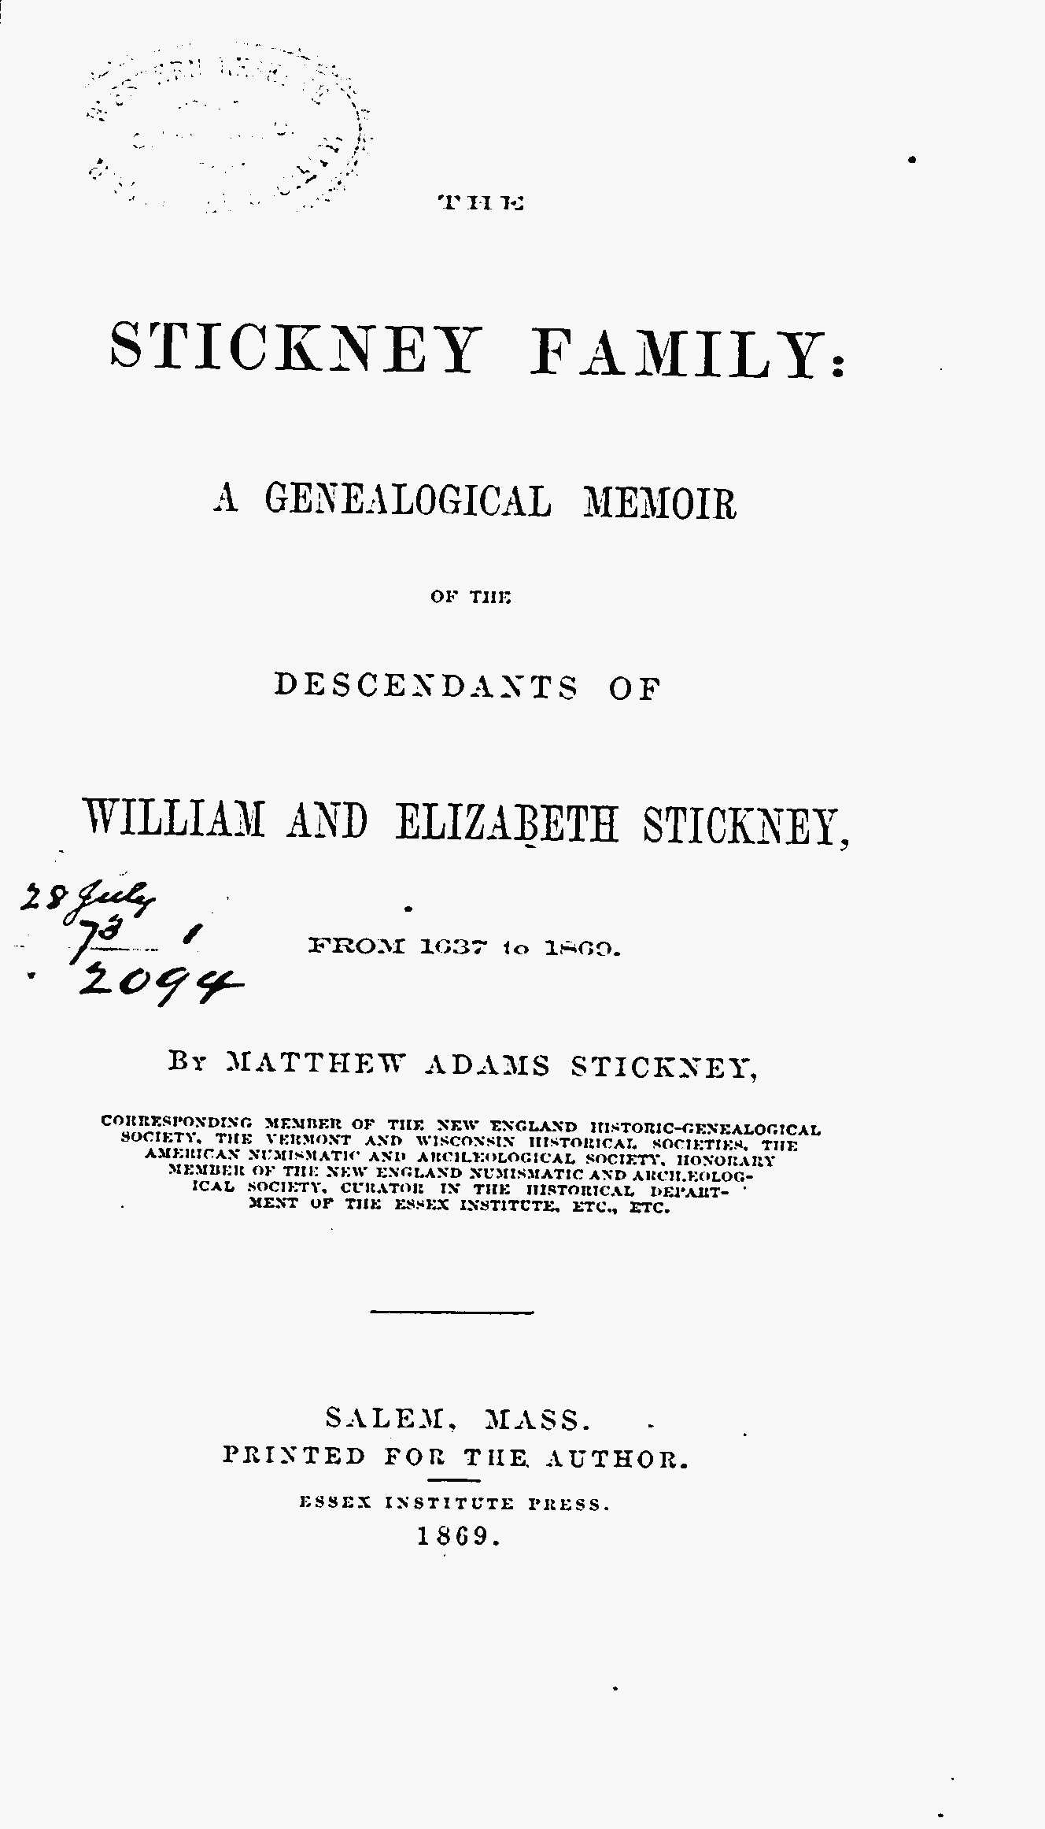
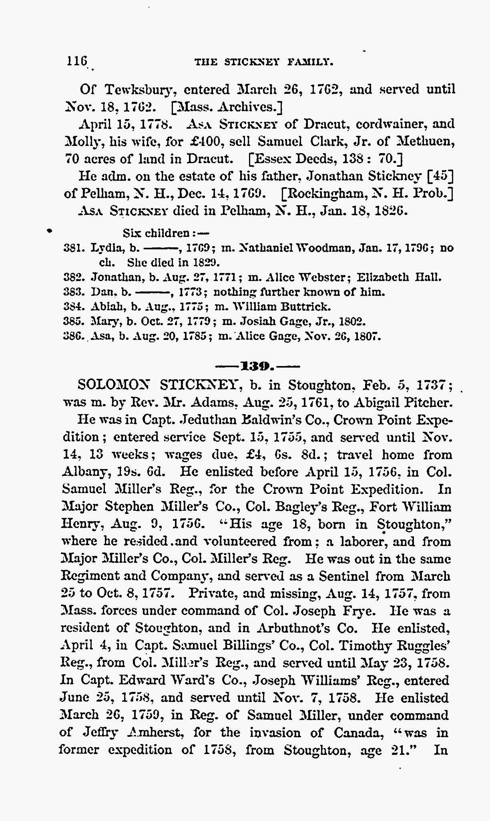
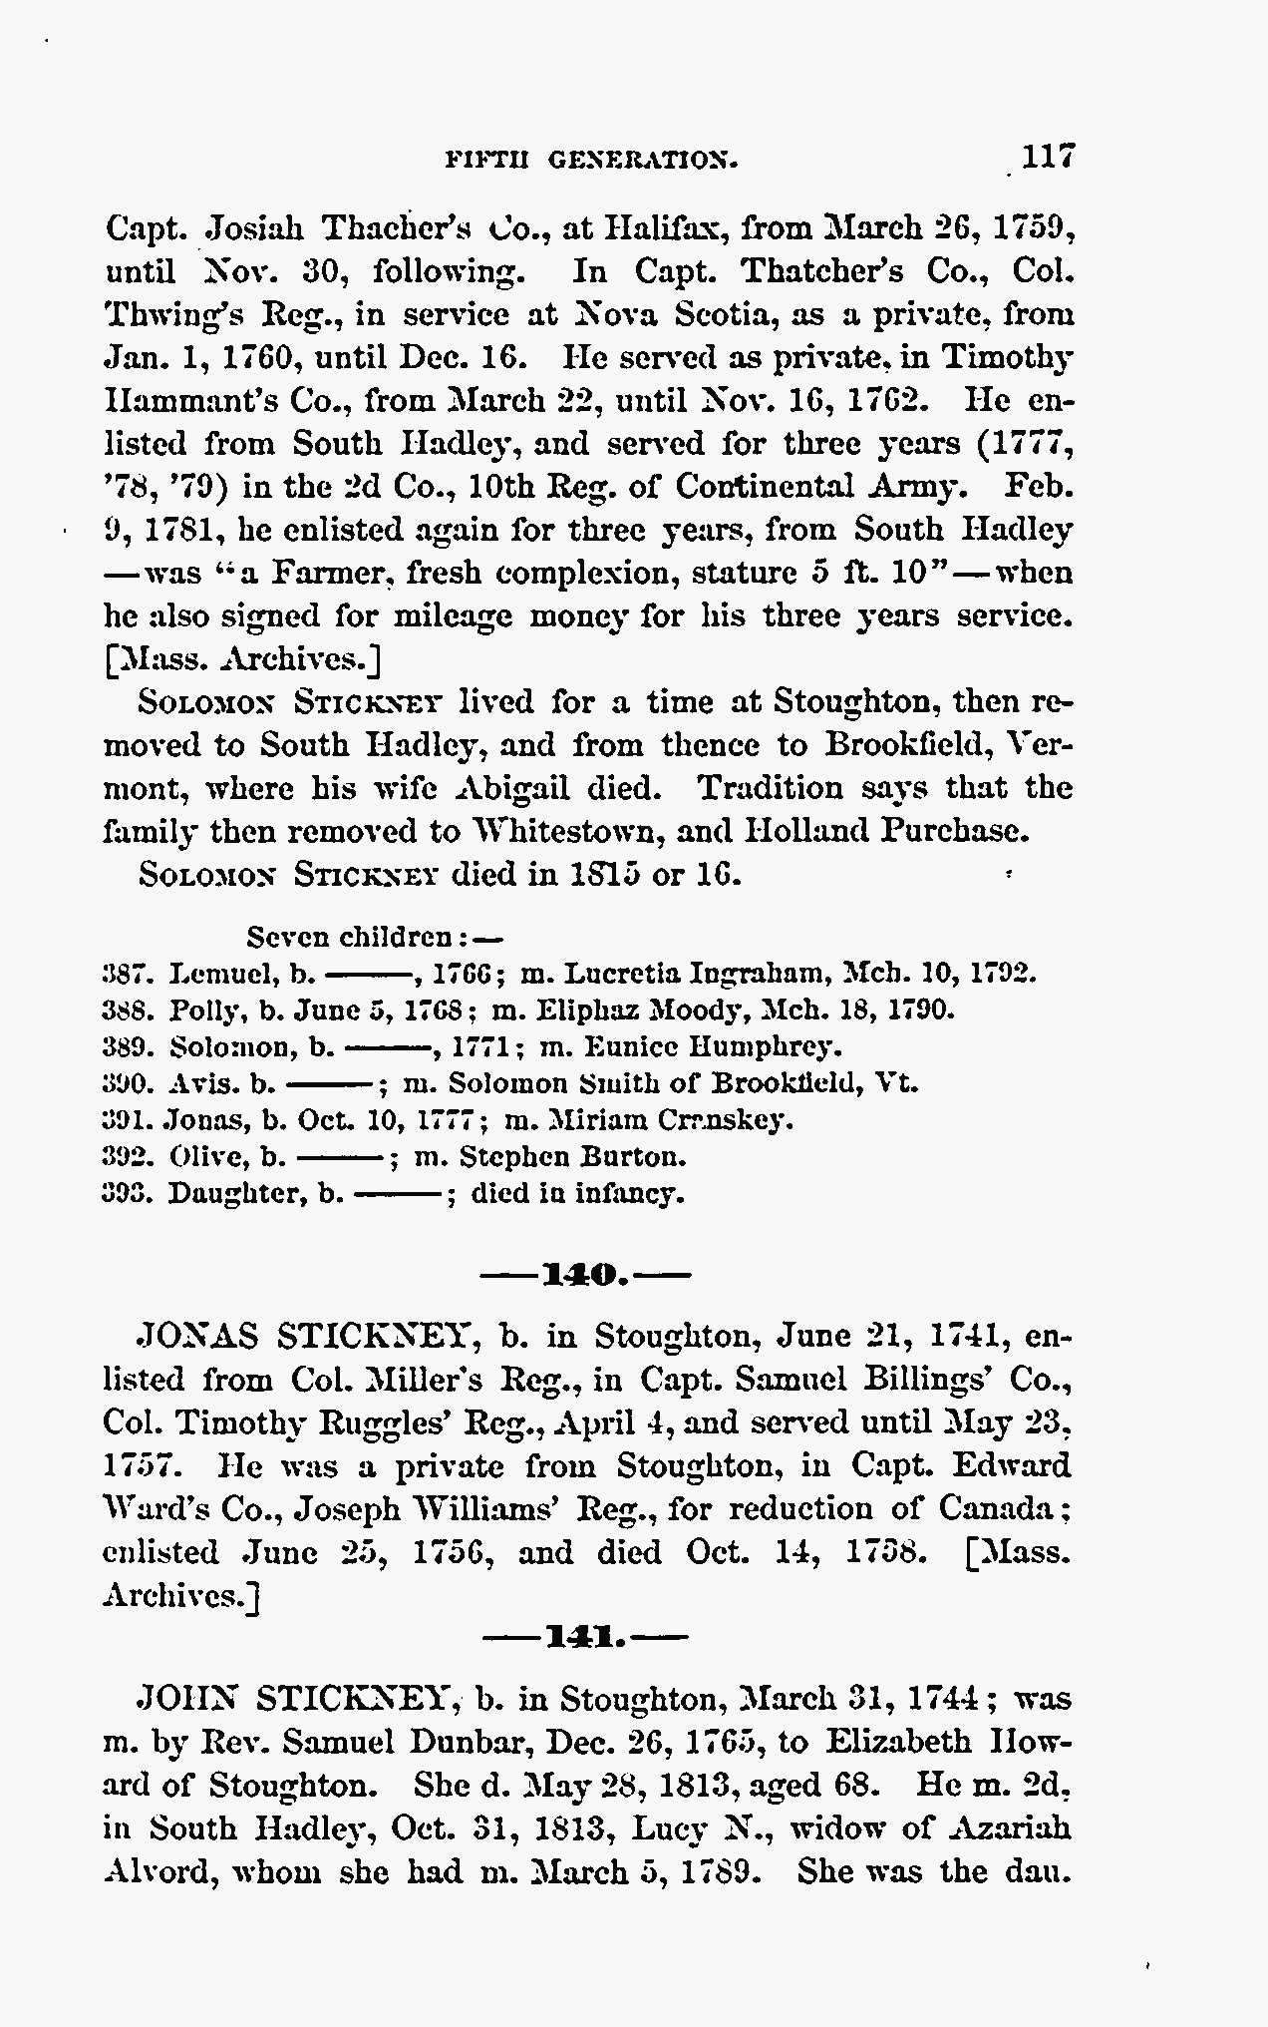

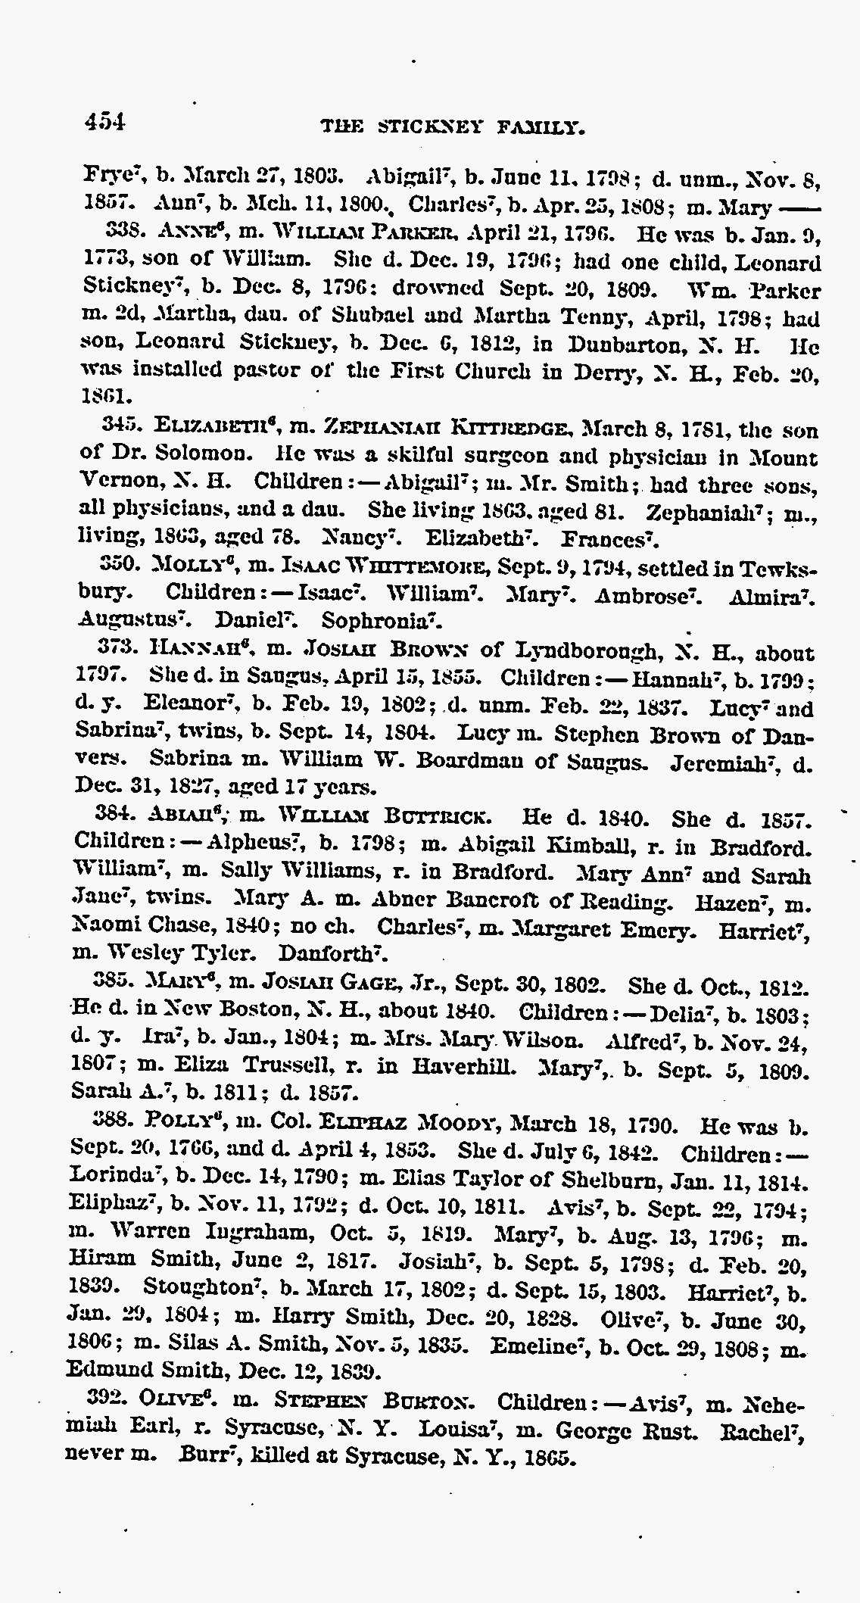
In the name of God Amen. I Solomon Stickney of Brookfield in Orange
County state of Vermont being weak in body but of sound and perfect
mind & memory do make a publish this my Last will and Testament
in manner and form following. --------- That is to say Imprimus
I give to my beloved wife Love Stickney all the Personal Property that
she brought with her when we were married and she came to Live
with me and all that she has since made or the value thereof in money
or other Property as good as what she brought with her. Also all my
wearing apparel. Item. I give to my daughter Olive Burton one feather
bed one bolster two pillows and cases one coverlid and two sheets. And as to
the remainder and residue of my Property wether real or Personal
of what kind name or nature what ever I give to my beloved wife
Love Stickney after my Just Debts are Paid. And I hereby appoint
Solomon Smith of Brookfield sole Executor to this my Last
will and Testament hereby revoking all former wills by me
made. In witness whereof I do hereunto set my hand
and seal this sixth day of September in the year of our Lord
one thousand eight hundred and eleven.
Solomon Stickney
Signed sealed Published and -------
to be the above named Solomon
Stickney to be his Last will and
testament in the Presents of us
who have hereunto subscribed our Nat Wheatley
names as witness in the Presents Eunice Wheatley
of the testator Nathe Wheatley Jr

