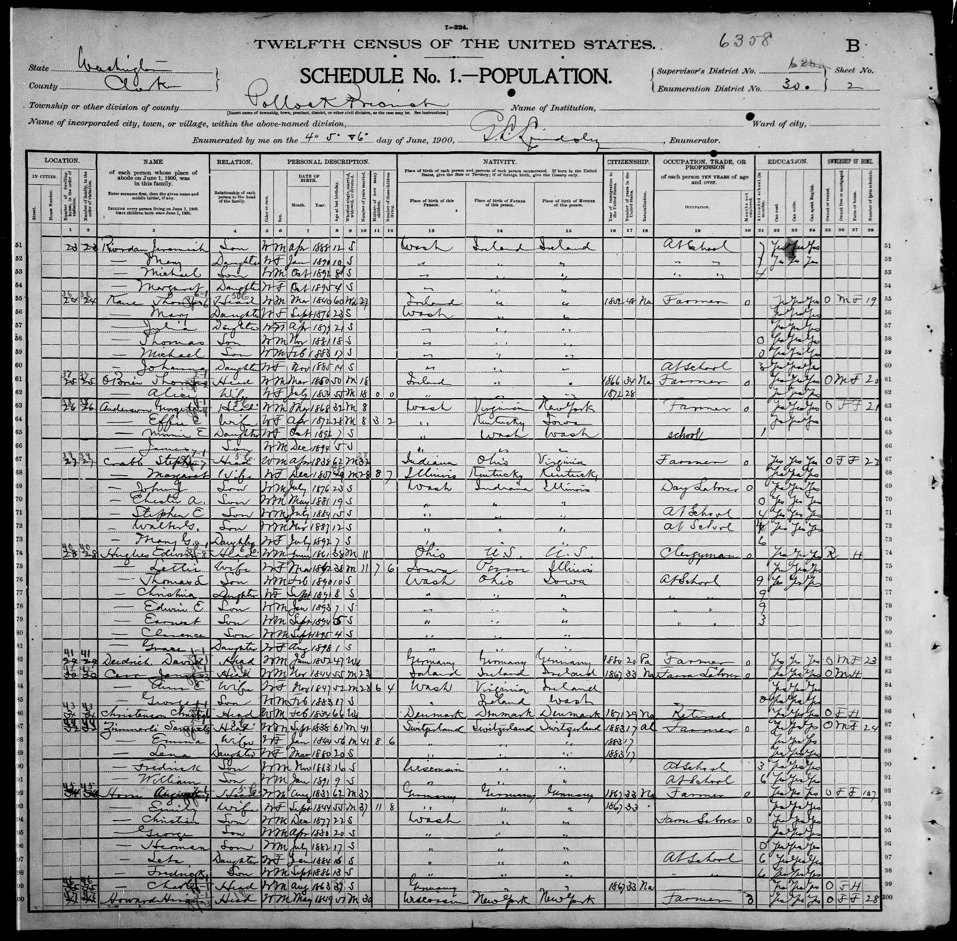

Cowlitz County, Washington
Marriage Records
1854 - 1900
A - I
Partial Listing

HOWARD, G H mar 9 May 1890 at res of Hugh Montgomery to Lillie Sams by William Huntington MG w Mary J Wilson and Clarinda Montgomery

HOWARD, L G of Castle Rock mar 16 Aug 1891 at Castle Rock to Amy E Smith of Castle Rock by Alson W Steers MG w C Mussleman and Una Mussleman

HOWARD, Nelson mar 27 Aug 1885 at res of Nelson Howard to Laura JARVEY by William Bybee PJ w John S Tooley and T J Taylor

HOWARD, Walter F and Cynthia BRAZEE LONR 14 Jan 1876 consent of father James Brazee

HOYER, Henry a 20 of Castle Rock b KSoc Farmer f Wm Hoyer m Cathren Hartman mar 5 Aug 1900 at Castle Rock to Flora Edmunds a 17 of Castle Rock b IA f JR Edmunds m Ella E Edmundson by T M Reese MG w George Edmunds and Dora Hoyer

HOYT, Richard and Rose Hoxie LONR 3 Jan 1874 aff’d C Morris

HUGHES, Edwin L (Rev) of South Prairie, Prc Co WA mar 1 May 1889 at res of bride Kelso to Lettie DAVOLT of Kelso by F M Pickles MG w Arthur Gunn and Jeanette Pratt

HUGHES, Joseph T of Kalama mar 14 Apr 1891 at Kalama to Emma M Crosby (Crossley on lic) of Kalama by Geo Baker MG w S W Beall and D H Gumm

HUGHS, A mar 31 Dec 1898 at Castle Rock to Jennie ZENOR by A D Sheldon JP w Mable Zenor and Ralph Zenor

HULS, David Mackey a 30 of Silver Lake b IA f David Huls m Lucinda Mackey mar 22 Dec 1891 at Toutle to Roxann M EVANS a 17 of Silver Lake b KSf George M Evens m Sarah Boyes by M A Covington MG w M S Evans and Mrs Belle Evans

HULSTROM, John mar 24 Sep 1899 at Toutle to J T ERICKSON by E S Ruth JP w Frank R Ruth and John Luebke

HUME, George W of Oak Point mar 28 Aug 1867 to Celia A HUNTINGTON of Monticello by J H B Royal MG w A S Abernathy and C E Huntington

HUNT, Oliver P mar 2 Jan 1881 at res of A J Birt to Mary J BIRT by C C Bozarth JP w John Robinson and J E Eaton

HUNTER, J G of Woodland mar 31 Jan 1897 at Woodland to Laura STRAIT of Woodland by T H Starbuck MG w W Strong Sr and Mary E Strong

HUNTER, Oscar E and Olive D GIRTY LONR 9 Dec 1875 afl'd C A Brown

HUNTINGTON, Alonzo G mar 23 Oct 1887 at res of C R Huntington to Florence BARBER (Biliew on lic) by T M Reese MG w N R Smith and Mrs Emma Smith

HUNTINGTON, Benjamin F mar 4 Jul 1871 to Upheme W BREWER f T W Brewer m Pernetia Brewer by J S Huntington JP w Wm Huntington and others

Generation 4
Gloria Morales Mata
Ancestor John McMurtry

Clarence Hughes – from his Military Records in the Descriptive Lst below, it states his Birth is in Castle Rock, WA and his Parents being Mrs. Lettie Hughes and Edwin l. (Lincoln) Hughes.

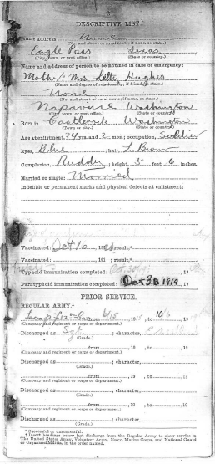

Generation 3 & 4
Gloria Morales Mata

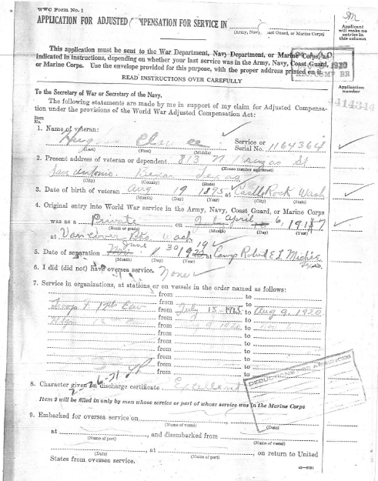

Clarence Hughes – No Marriage Certificate, but 1926 City Directory in San Antonio, TX show Clarence and Vivian Hughes living at 1317 Burleson.

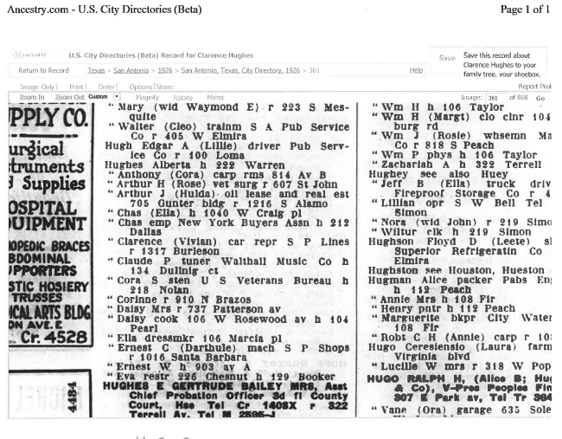

Generation 4 Gloria Morales Mata
Ancestor John McMurtry

Clarence Hughes – No Marriage Certificate, but 1930 Bexar County Census in San Antonio, TX show Clarence and Vivian Hughes Household

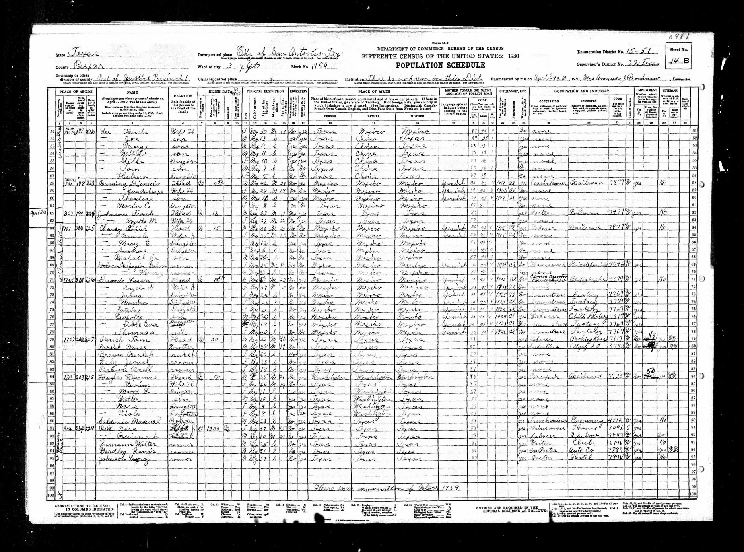

Generation 4 Gloria Morales Mata
Ancestor John McMurtry

Edwin Lincoln Hughes OBIT

OBIT
Napavine, Sept. 15, 1927—Rev. Edwin Lincoln Hughes, for the past eleven years a respected resident of this city; died at the family home Wednesday night, aged 65 years. Death resulted from a series of paralytic strokes suffered over a period of recent years. Reverend Hughes was for forty, years a member of the Puget Sound conference of the Methodist Episcopal church. He had lived at various times during his ministerial work in different cities of Washington. He retired from the ministry in 1920. During his active life he filled several local positions of trust, having been city clerk at
Toledo and at Napavine and postmaster here from 1922 to 1926. At Toledo and La Center he had also acted as town marshal. Reverend Hughes had lived thirty years in Lewis county.
Surviving relatives include the widow, Mrs. Lettie Hughes; two daughters, Mrs. Christina Martin and Miss Lettie Hughes of Napavine; six sons, Earl, Earnest and William' of Napavine; Roy and Bowman of Centralia, and Clarence of San Antonio, Texas; also 21 grandchildren. Two sisters reside in Ohio, Mrs. B. B. Bowman at Canal Winchester and Mrs. B. F. Kauffman at Columbus.
Funeral services will be held at the Methodist church in Centralia at 2:30 Sunday afternoon, directed by C. L. Sticklin. Burial will be at Mt. View.

Generation 4 Gloria Morales Mata
Ancestor John McMurtry
Edwin Lincoln Hughes
Funeral Service Notice

JOURNAL of the Forty-fourth Annual Session of the Puget Sound Conference of the Methodist Episcopal Church.
Held at Seattle Washington, September 15th to 19th, Nineteen Hundred and Twenty-Seven. William O. Shepard, D D., LL. D., Presiding Bishop, Portland, Oregon. Robert C. Hartley, Secretary. Aberdeen, Washington. OFFICIAL RECORD, Published by Order of the Conference. Editors: Robert C. Hartley, Secretary. Fred L. Pedersen, Statistician, Roy L. Sprague, Treasurer. VII. Memoirs: EDWIN LINCOLN HUGHES. Edwin Lincoln Hughes was born in Delaware, Ohio, June 3, 1862, and died at his home in Napavine, Washington, September 14, 1927, the date of the opening session of the Puget Sound Conference, of which he was a retired member.
The funeral was held in the First Methodist Episcopal Church, Centralia, Wash., Sunday, September 18, the writer conducting the service. A large number of friends from the charges

where he had served in his ministry attended the funeral and the floral display was beautiful covering the chancel and platform. Interment was in the cemetery north of Centralia.
In the Journal of the Puget sound Conference for 1886, in the report of the Olympia District, A.J. Hanson, Presiding Elder, is the following: "Lewis River Circuit. On this extended field, G.G. Ferguson has just completed his third year. Shortly after Conference, Edwin L. Hughes, a local preacher from Delaware, Ohio, a young man of good abilities and excellent spirit, was put on the work as assistant pastor, and rendered excellent service." In that same report, under the head of Cowlitz Circuit, it reads: "Since the middle of June, Brother Hughes, late assistant on the Lewis River work, has been in charge, and matters have assumed a better shape." At this Conference session the name of E.L. Hughes appears in the list of those admitted on trial and he was appointed to the Cowlitz Circuit. Besides these two large Circuits, Brother Hughes served as pastor at Kelso, South Prairie, Skamokawa, Willapa, Castle Rock, Pe Ell, Pioneer, Winlock, Oakville, Satsop and Toledo. With the exception of one year, he served all his ministry within the bounds of the Vancouver District and much of that time on charges that were developed from the two Circuits he served the first year of his ministry.
On May 1, 1889, Brother Hughes was united in marriage with Lettie Davolt, at Kelso, Washington. To this union was born eleven children, eight of whom are still living. He is survived by his widow, Mrs. Lettie Davolt Hughes; two daughters, Mrs. W.H. Martin and Lettie Hughes, of Napavine, and six sons, Roy and Bowman of Centralia, Ernest, Earl and William of Napavine and Clarence, who resides in San Antonio, Texas; also 21 grandchildren. Two sisters reside in Ohio. --- Spencer S. Sulliger.

Generation 4 Gloria Morales Mata
Ancestor John McMurtry

Lettie Davolt Hughes OBIT

OBITUARY
Mrs. Hughes Passes Away
Mrs. Lettie Davolt Hughes, 94, a resident of Napavine from 1916 to 1954, passed away Friday in Tacoma at the home of her daughter, Mrs. Christina Martin, where she had been living for the past 18 months.
Born March 4, 1862, in Des Moines, Iowa, Mrs. Hughes was a member of the Methodist church and Rebekah lodge at Napavine.
Survivors include six sons, Roy, Seattle; Ernest and William, Tumwater; Earl, Vancouver; Bowman, Centralia, and Clarence, San Antonio, Texas; two daughters, Mrs. Martin and Mrs. Lettie Woosley,
Tacoma; a sister, Mrs. Emma Nelson, Kelso; 35 grandchildren; 35 great-grandchildren; two great-great-grandchildren and many nieces and nephews.
Funeral services will be held Thursday at 1:30 pm at the Sticklin chapel in Centralia with Rev. S. Raynor Smith officiating. Interment will follow in Mountain View cemetery. Rebekah lodge of Napavine will have charge of graveside services.

Generation 4 Gloria Morales Mata
Ancestor John McMurtry

Edwin L. and Lettie Hughes Head Stone

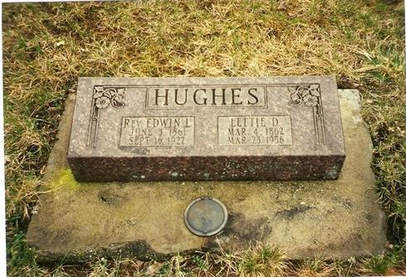

Mountain View Cemetery
Centralia, Lewis Co, WA

Generation 4 Gloria Morales Mata
Ancestor John McMurtry

An Interesting OBIT of Charles Davolt, brother of (Lettie Davolt Hughes). It gives a description of how the Pioneer Davolt Family Left Henry County, Iowa in 1873 to settle in Cowlitz County WA, and surrounding areas. Obit references Mrs. Ed Hughes Mrs. Edwin Lincoln Hughes (Lettie Davolt)
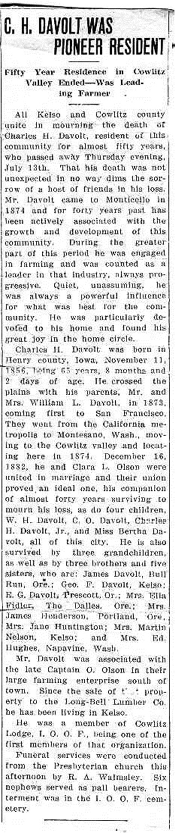
Generation 4 Gloria Morales Mata
Ancestor John McMurtry
Lettie Davolt
Lettie Davolt 8 years old, daughter of William and Catherine Davolt
1870 US Census, Polk County Iowa
Davolt’s – William line 6, Catharine line 7, Lettie Line 11
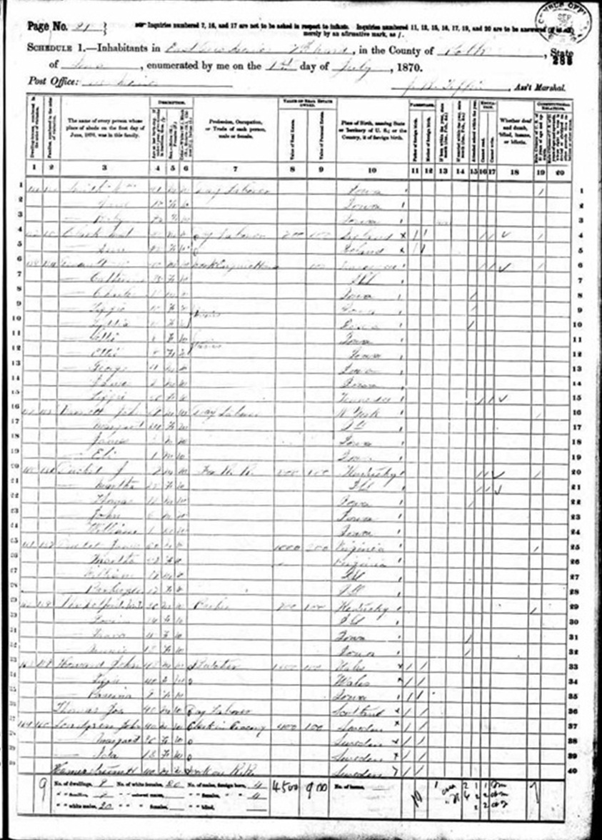
Generations 4 & 5 Gloria Morales Mata
Ancestor John McMurtry

Lettie Davolt 8 years old, daughter of William and Catherine Davolt
Davolt’s – William line 6, Catharine line 7, Lettie Line 11
Expanded View of 1870 US Census, Polk County Iowa

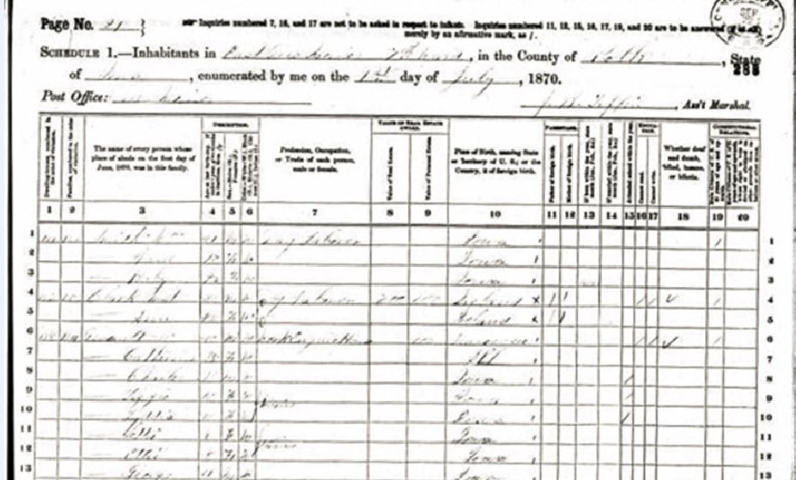

Generations 4 & 5 Gloria Morales Mata
Ancestor John McMurtry

Lettie Davolt 18 years old, daughter of William and Catherine Davolt
1880 US Census, Cowlitz County WA

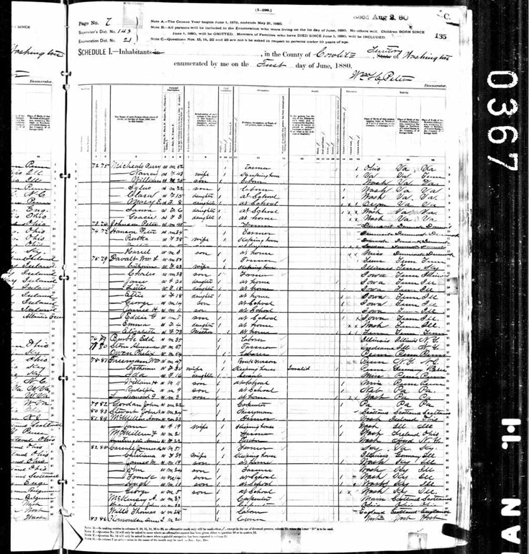

Generations 4 & 5 Gloria Morales Mata
Ancestor John McMurtry

Lettie Davolt 23 years old, daughter of William and Catherine Davolt
Davolt’s, Elizabeth Line 21 (William’s Mother), William Line 22, Catherine Line 23, Lettie Line 24
1885 Territory Census, Washington, Cowlitz County
&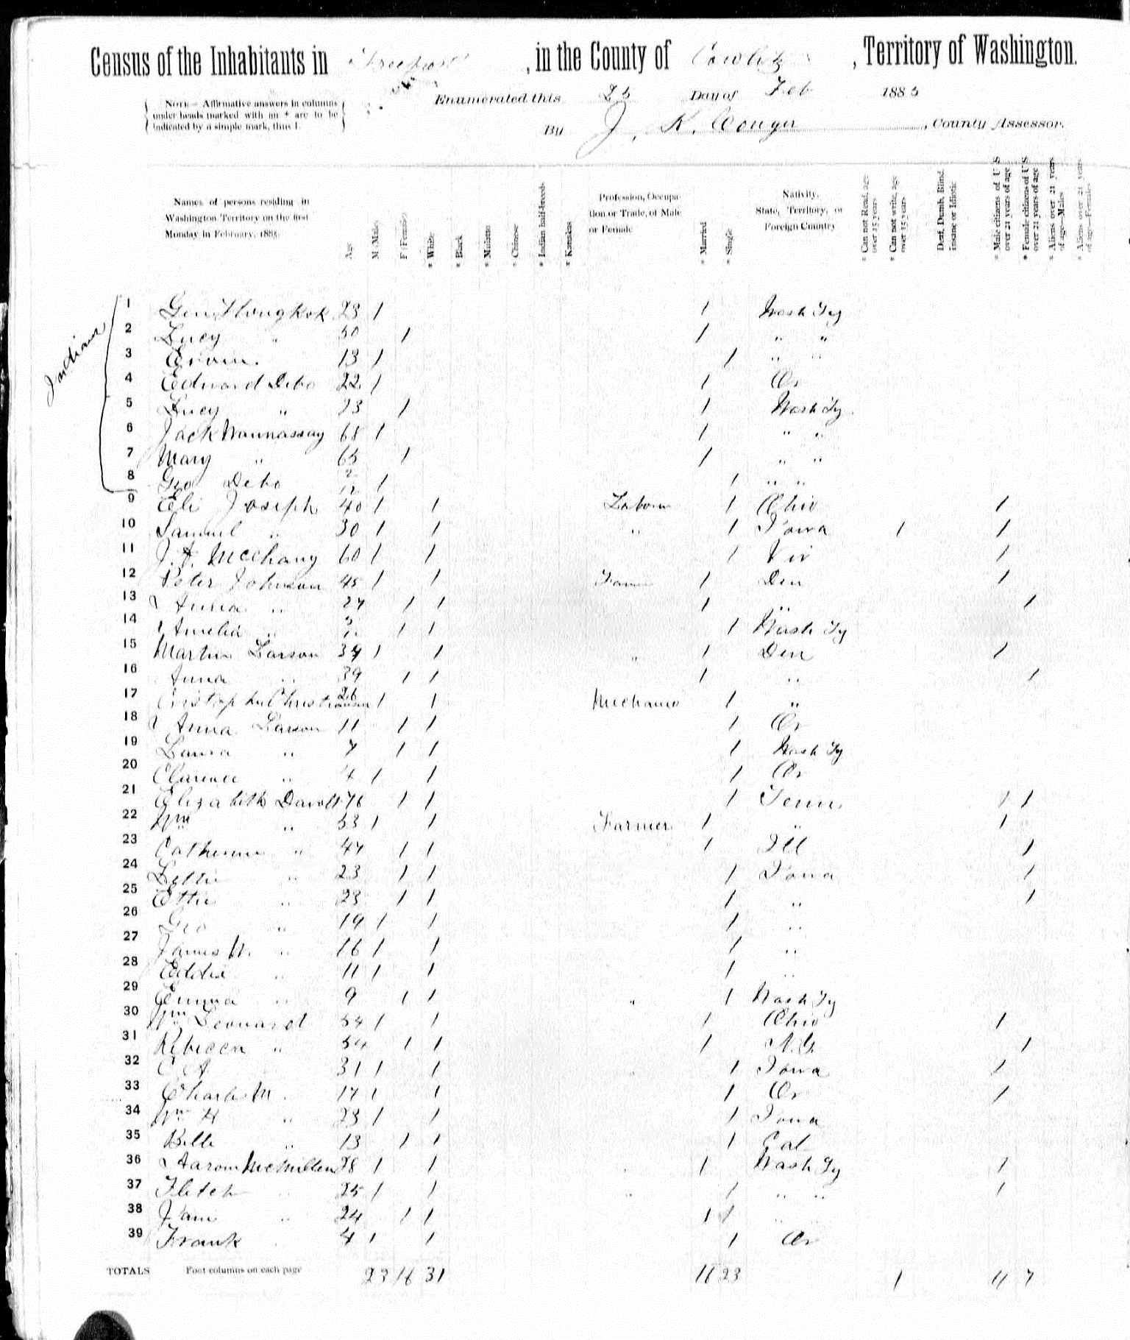

Generation 4 & 5 Gloria Morales Mata
Ancestor John McMurtry
Find a Grave for William L. Davolt & Catherine Jones Davolt

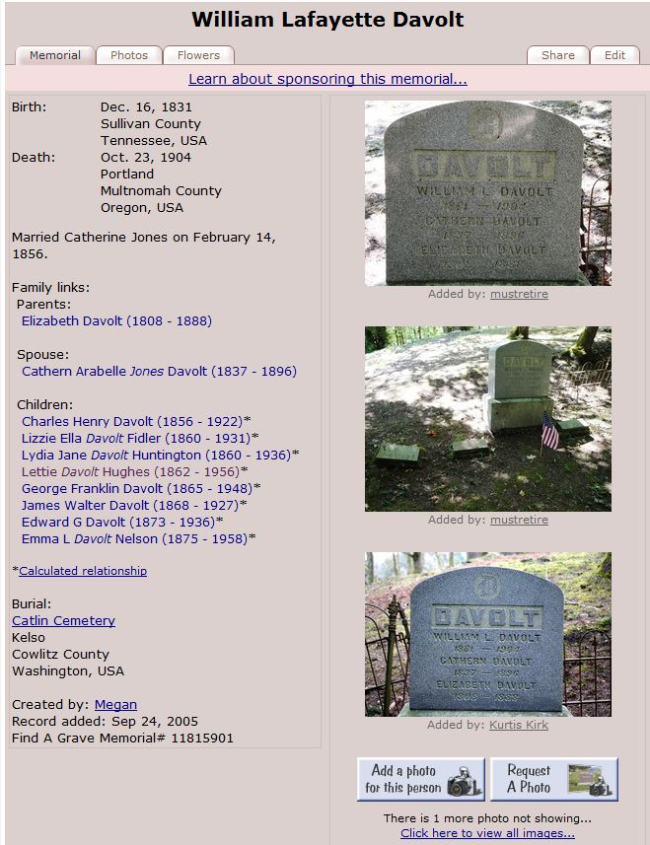

Generation 4 & 5 Gloria Morales Mata
Ancestor John McMurtry

