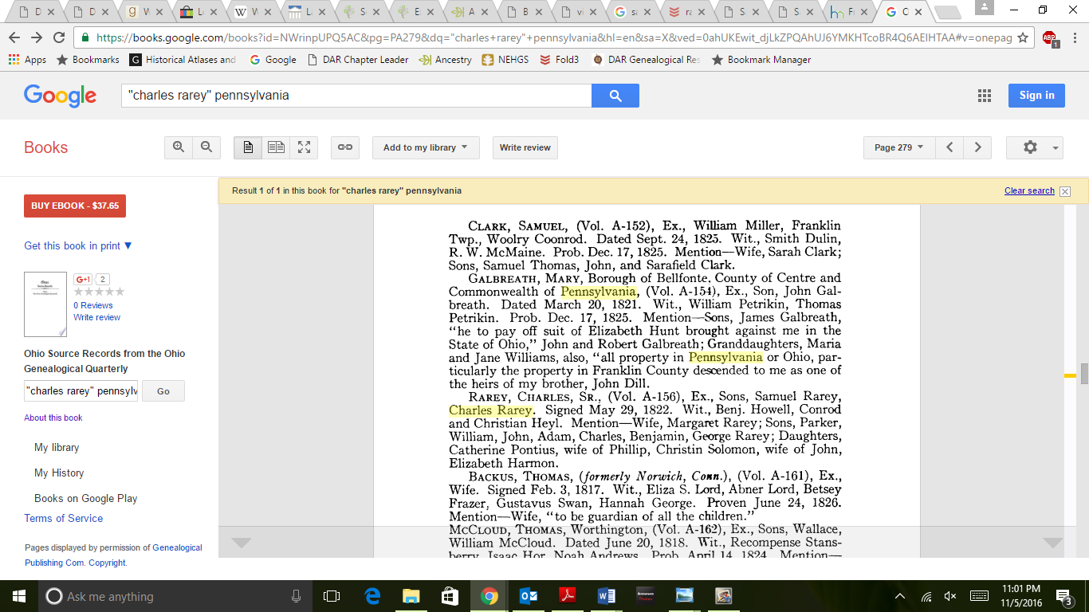
For Mata –
http://www.genealogybug.net/Franklin_Cemeteries/rarey/rarey.htm
http://person.ancestry.com/tree/67624192/person/34165805876/facts
Edwin Lincoln Hughes – Lettie Davolt
Thomas Leroy Hughes – Christina Rarey
Charles Rarey, Jr – Mary Kramer b. Maryland 1792 (possibly below???)
Charles Rarey, Sr – Margaret Wolf – see will above.
He probably paid taxes in either Pennsylvania or Virginia during the war. Nothing listed on DAR

Maria Elisabetha Kraemer
Maryland, Church Records
Name | Maria Elisabetha Kraemer
Event Type | Christening
Event Date | 30 Mar 1793
Event Place | First German Reformed Church Baltimore, Baltimore, Maryland, United States
Gender | Unknown
Birth Date | 13 Jun 1792
Father's Name | Friedrich Kraemer
Mother's Name | Catharine

Citing this Record
Maryland, Church Records, 1668-1995, database, FamilySearch(https://familysearch.org/ark:/61903/1:1:F4ZK-CZP : 24 February 2016), Maria Elisabetha Kraemer, 30 Mar 1793; citing Christening, First German Reformed Church Baltimore, Baltimore, Maryland, United States, various libraries, churches, historical and national societies, private and public records; FHL microfilm 13,700.

- No image available

Maryland, Church Records, 1668-1995
GS Film Number | 000013700
Digital Folder Number | 007575954
Image Number | 00492

