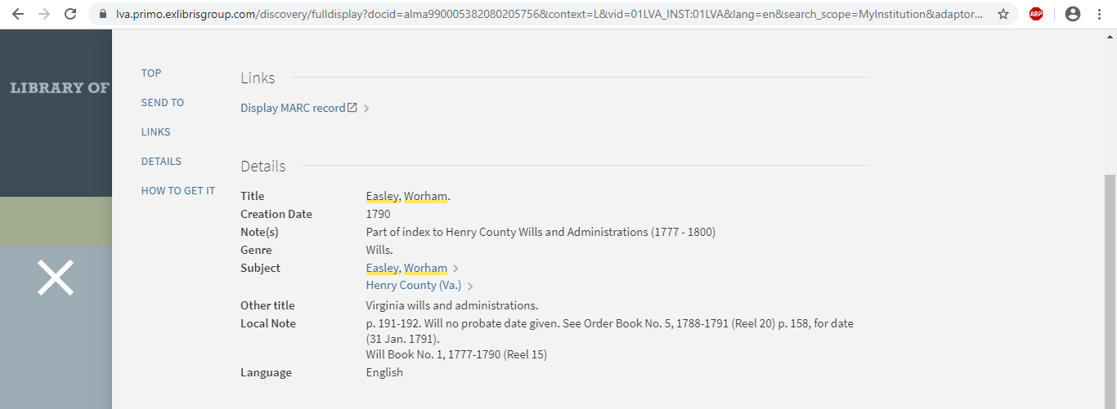
Jamestowne link
Easley, Warham (ca 1716 - 1790-1791) married Anne Woodson (1736 - 1801) – QA John Woodson A9103

Henry Co., VA, Will Book 1, p. 191.The Last Will and Testament of Warham Easley.
In the name of God, Amen -- I, WORHAM EASLEY, being in perfect mind and memory tho weak in body do make this my last Will and Testament in manner and form following, to wit:After all my just debts are paid,
Item, I give and bequeath to my beloved son JOHN EASLEY, five shillings, to him and his heirs forever.Item, I give and bequeath to my beloved son MILLER EASLEY, five shillings to him and his heirs forever.ITEM, I give and bequeath to my beloved daughter SUSANAH FRANCES, five shillings to her and her heirs forever.Item, I give and bequeath to my beloved son DANIEL EASLEY five shillings to him and his heirs forever.Item, I give and bequeath to my beloved son JOSEPH EASLEY five shillings to him and his heirs forever.Item, I give and bequeath to my beloved son WORHAM EASLEY, the tract of Land whereon he now lives to him and his heirs forever.Item, I give and bequeath to my beloved son WILLIAM EASLEY, the tract of land whereon I now live, (lying part in Virginia and part in North Carolina), and one black blaze faced filly, to him and his heirs forever.Item, I give and bequeath to my beloved daughter JUDAH EASLEY, one negro girl named Lucy and my wilks mare to her and her heirs forever.Item, I lend unto my well beloved wife NANNEY EASLEY all of my other Estate not given away heretofore, of every kind during her Natural life, and my will and desire is that my well beloved wife at her death shall give the above Lent Estate to such of my children as she thinks proper and I do acknowledge by these presents that her will shall be good and valid to them in Law, and lastly I constitute and appoint my well beloved wife, NANNEY EASLEY and my beloved son MILLER EASLEY, my whole and sole Executors to this my Last Will and Testament.
In witness whereof I have hereunto set my hand and seal this twelfth day of August in the year of our Lord One thousand Seven Hundred and Ninety.
Worham (X) Easley
Signed sealed and delivered in presence of John Marr, Susannah Marr, Sarah (X) Walker
NOTE: While there is currently no direct evidence that this particular Daniel Easley was the son of Warham and Ann (Woodson) Easley, the use of the name "Miller Woodson" among his descendants in Stanly Co., N.C. raises the identification to a very high level of probability. https://wc.rootsweb.com/trees/127662/I00227/daniel-easley/individual

Johnson, Our Easley Family and their Relatives, p. 12:
The date of his marriage to Ann Woodson was in 1752 or 53.
She was born in the year 1736, in what is now Cumberland County, Virginia.She was not more than 16 or 17 years old at the time of her marriage to Warham Easley. The largest Woodson site on the internet, WOODSON Genealogy - VA (Henrico, Isle of Wight, Cumberland) at:
http://www.martygrant.com/gen/woodson.htmhttp://www.martygrant.com/gen/woodson.htm

