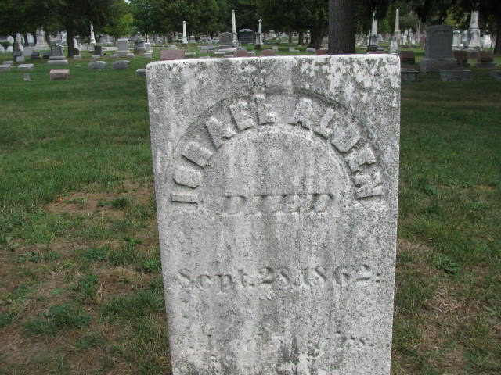

ISRAEL ALDEN
Died
Sept. 28, 1862
Brookside Cemetery
Tecumseh, Lenawee Co, MI

