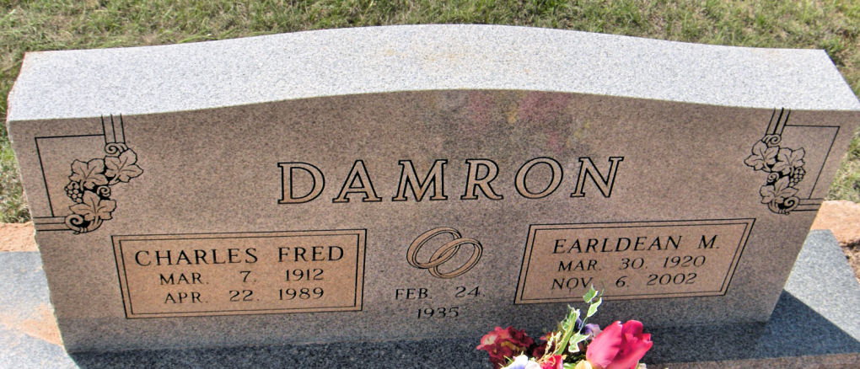
Crews Cemetery
Winters, Runnels Co, TX

