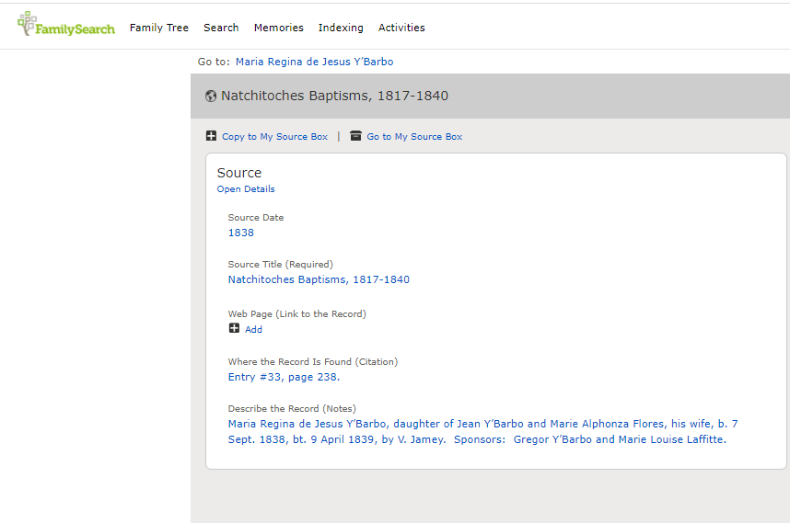
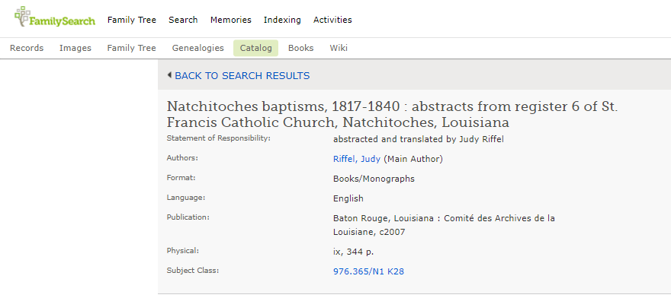
Natchitoches Baptisms, 1817-1840, Abstracts from Register 6 of St. Francis Catholic Church, Natchitoches, Louisiana
by Judy Riffel
2007 - 344 pages soft cover
Abstracts of baptisms from the Catholic Church at Natchitoches, La. Includes full-name index.
$44.00 (Non-Members)
$34.00 (Le Comite' Members)
http://www.lecomite.org/publications.html

