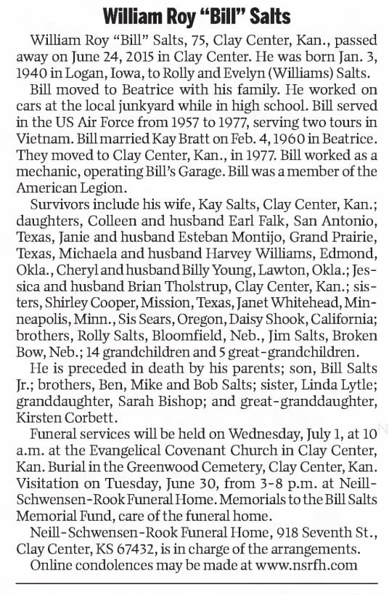
Beatrice Daily Sun (Beatrice, NE), 26 Jun 2015, Page A2, newspapers.com
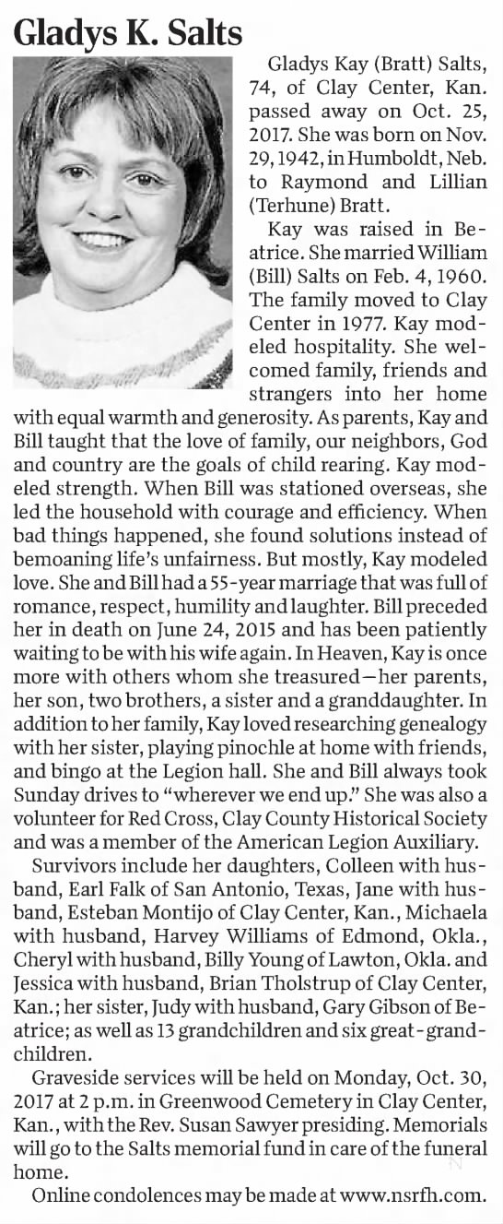
Beatrice Daily Sun (Beatrice, NE), 28 Oct 2017, Page A2, newspapers.com
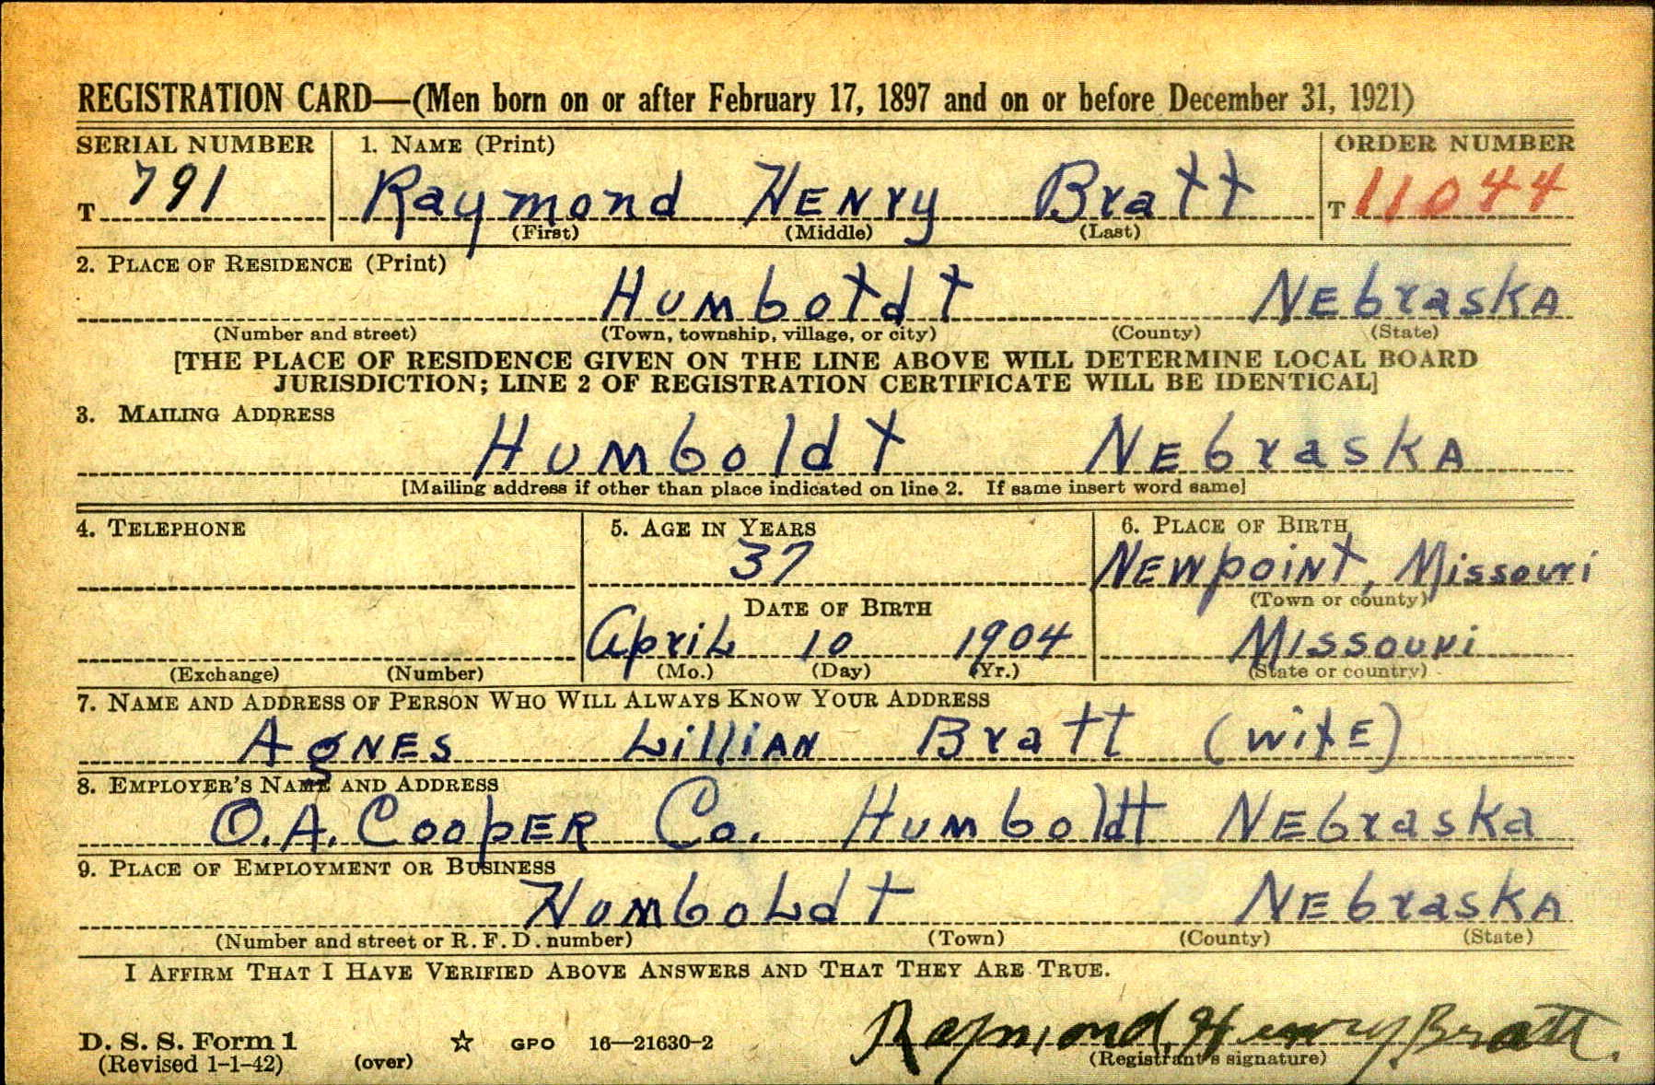

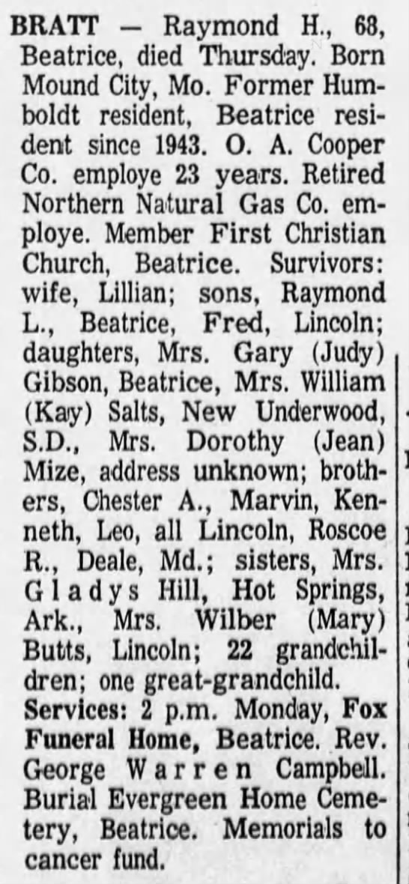
Lincoln Journal Star (Lincoln, NE), Friday, 10 Nov 1972, Page 24, newspapers.com
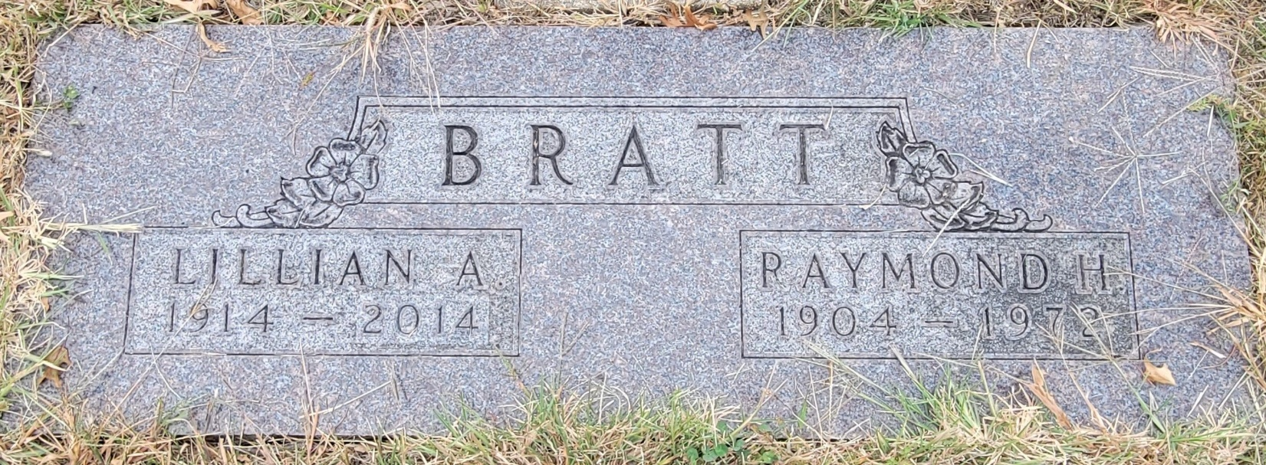

BRATT

LILLIAN A. RAYMOND H.
1914 – 2014 1904 - 1972

Evergreen Home Cemetery
Beatrice, Gage Co, NE

Find a Grave Memorial #168608777
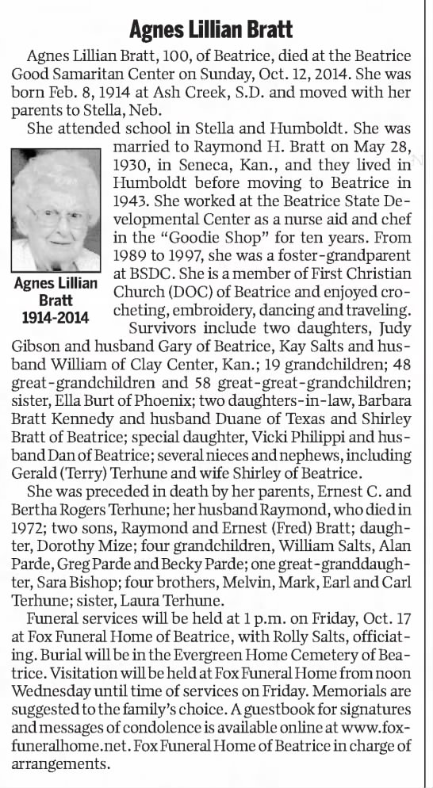
Beatrice Daily Sun (Beatrice, NE), 14 Oct 2014, Page A2, newspapers.com
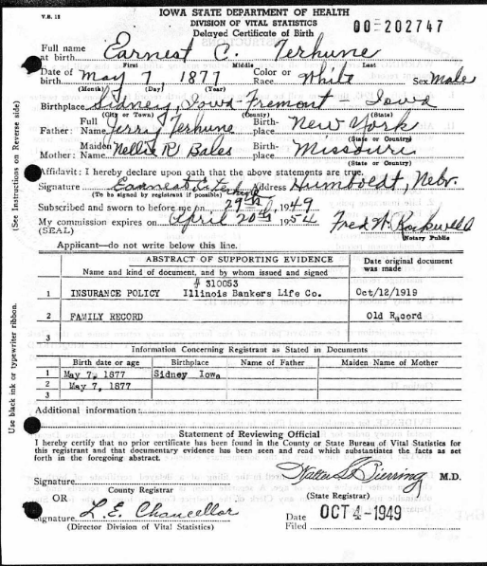
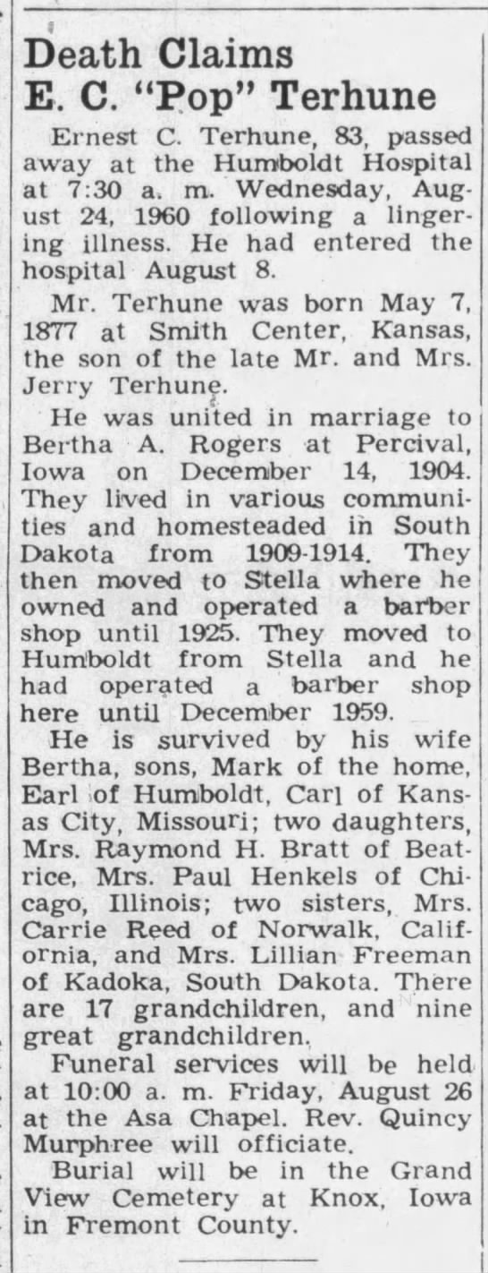
The Humboldt Standard (Humboldt, NE), 25 Aug 1960, Page 1, newspapers.com
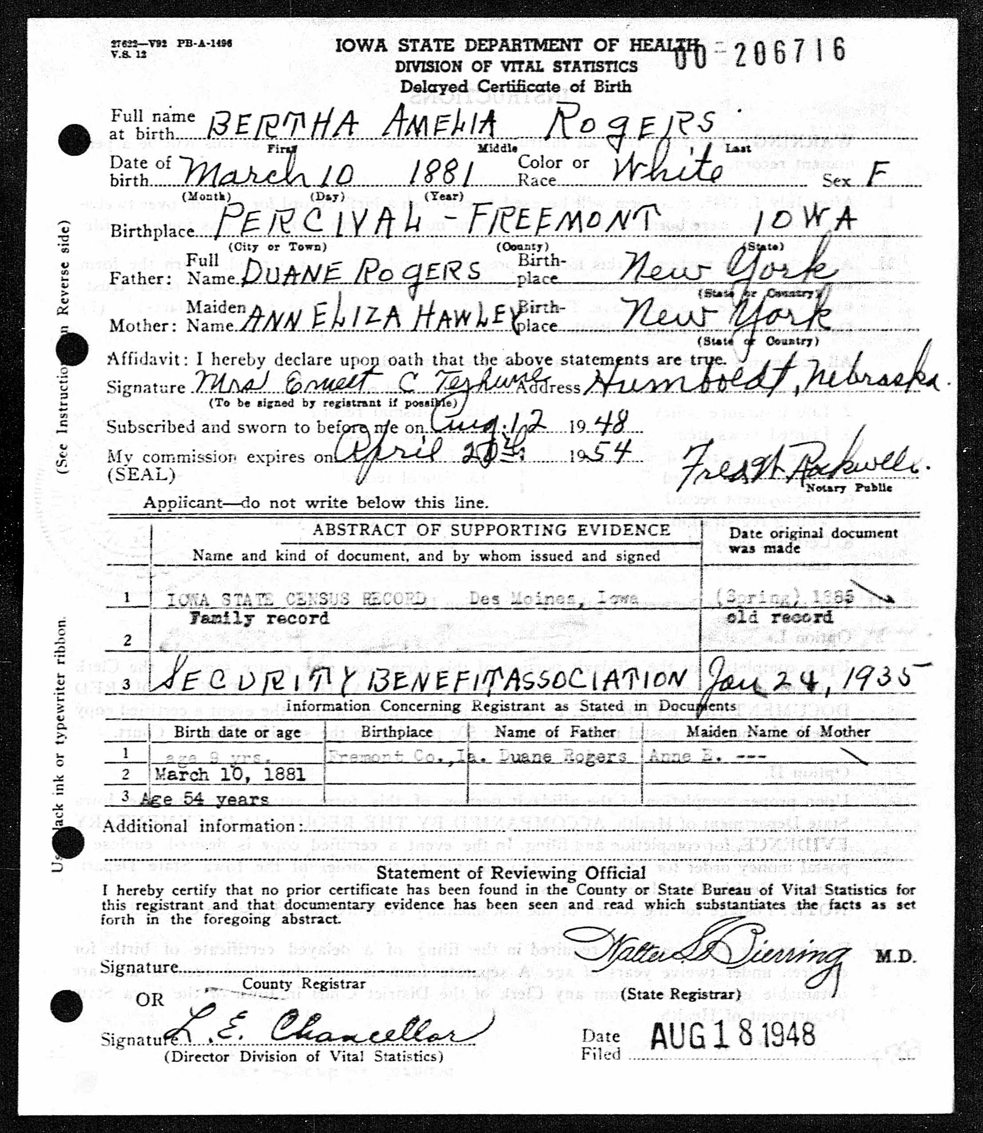

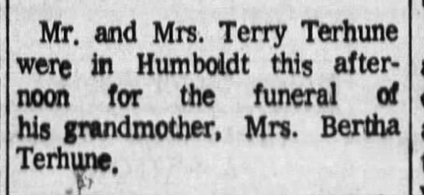

Beatrice Daily Sun (Beatrice, NE), 30 Apr 1969, Page 15, newspapers.com
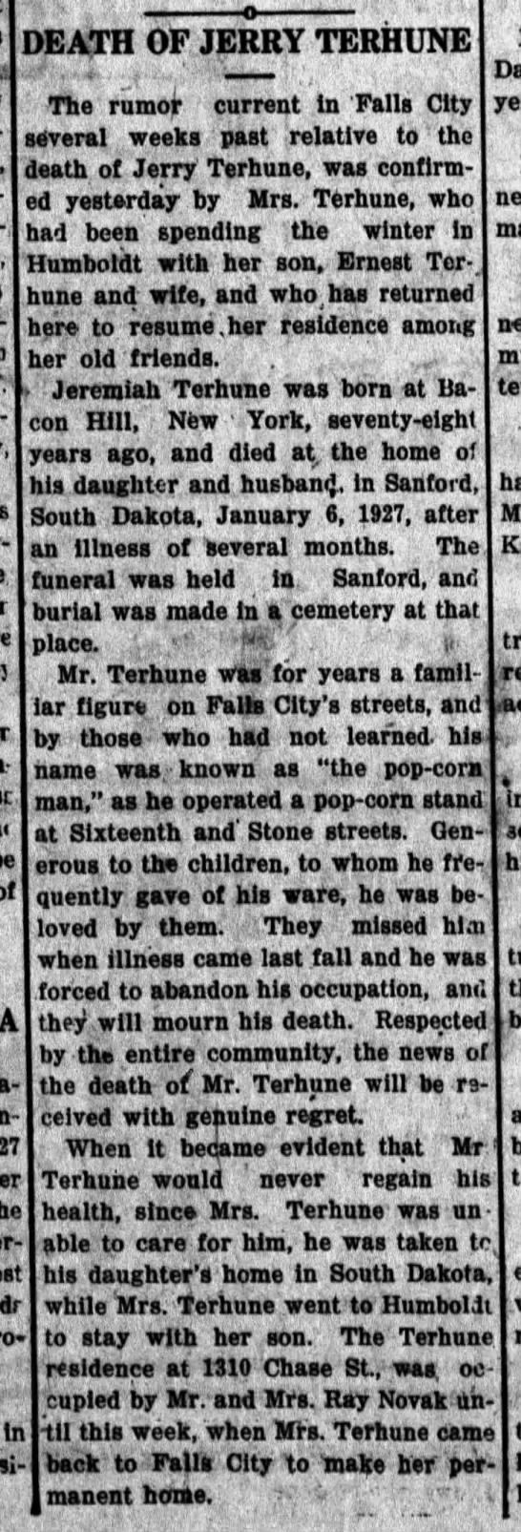
Falls City Daily News (Falls City, NE), 13 Apr 1927, Page 1
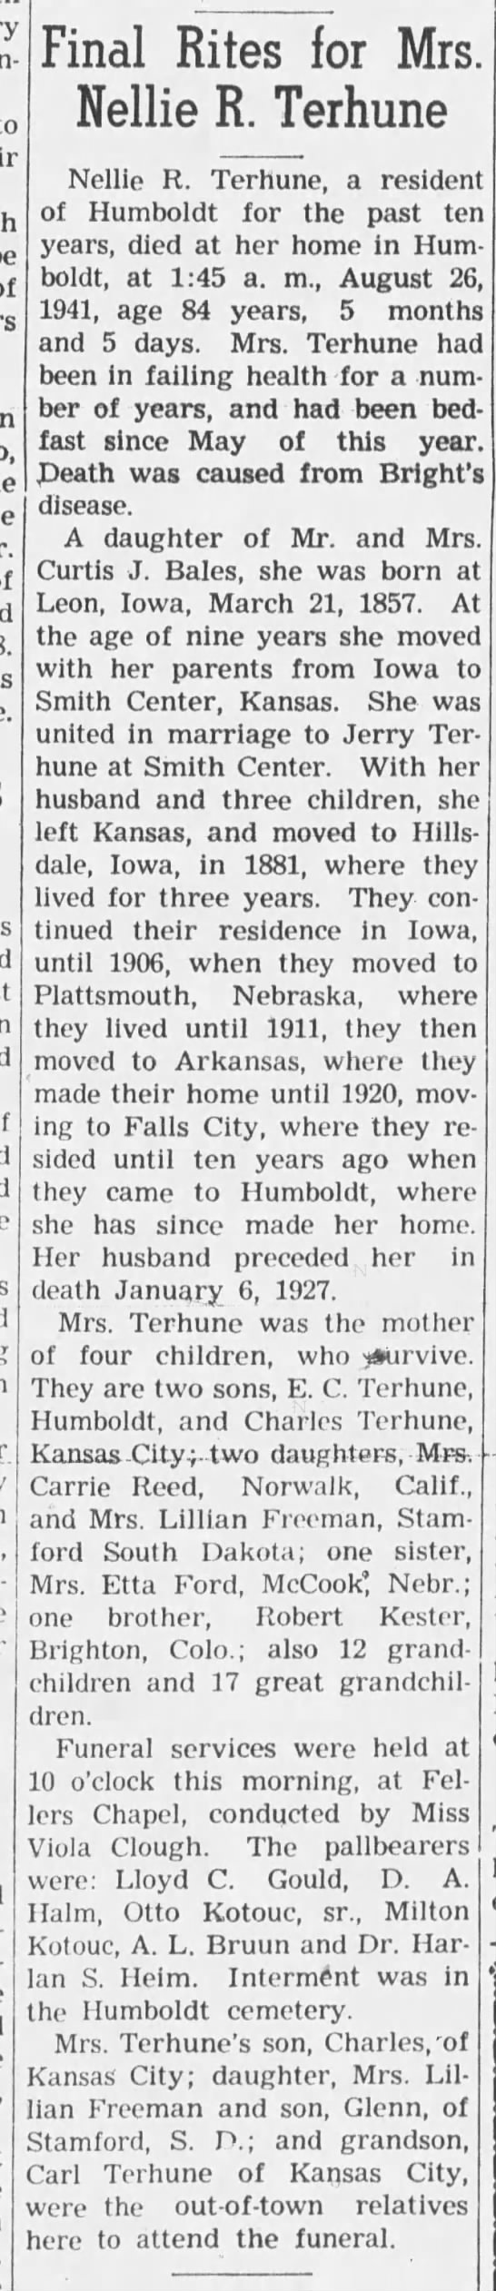
The Humboldt Standard (Humboldt, NE), 28 Aug 1941, Page 1
