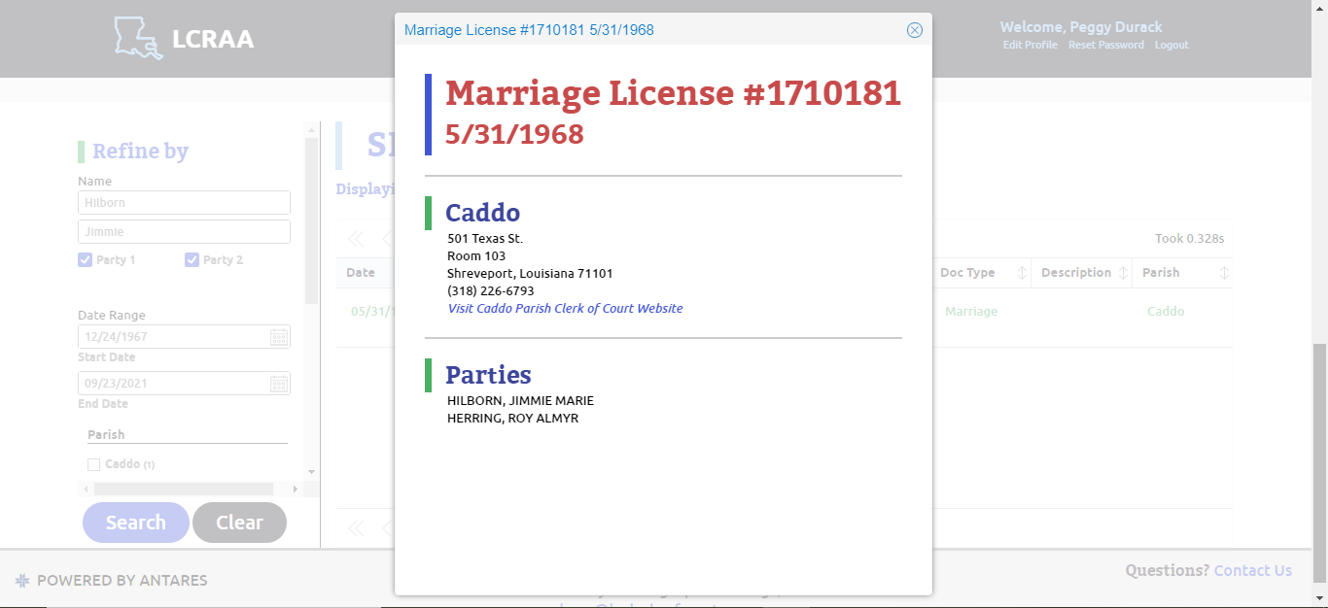

Please send requests along with a check or money order for $6.55 to:
Caddo Parish Clerk of Court
Attention: Marriage Department
501 Texas Street, Room 103
Shreveport, LA 71101

This is to request a copy of the actual marriage license / long form marriage certificate that includes parent names and birth information for the above couple.

Send to: Hollie Bordelon
149 E. Hollywood Ave
San Antonio, TX 78212-2310

Enclosed is check in the amount of $6.55.

Thank you!

