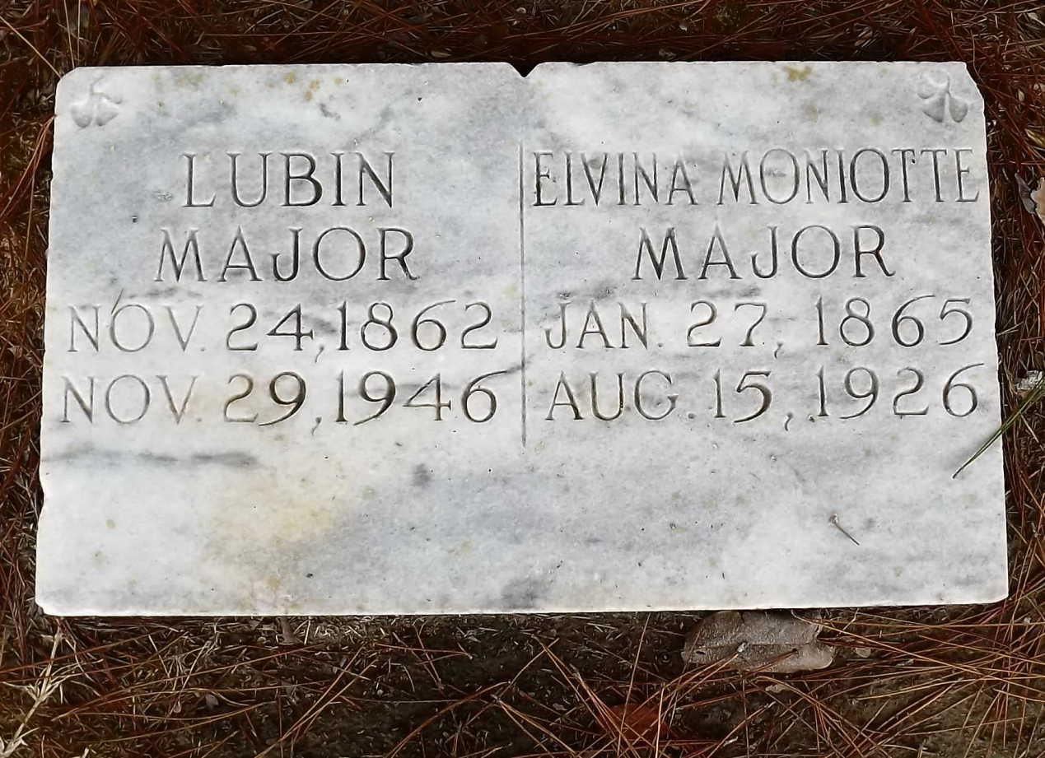

Find a Grave, database and images (https://www.findagrave.com : accessed 06 April 2021), memorial page for Lubin Jean Baptiste Major (24 Nov 1862–29 Nov 1946), Find a Grave Memorial no. 93304980, citing Chenal Cemetery and Mausoleum, Lakeland, Pointe Coupee Parish, Louisiana, USA ; Maintained by Cade Brown (contributor 47628545) .

Find a Grave, database and images (https://www.findagrave.com : accessed 06 April 2021), memorial page for Elvina Moniotte Major (27 Jan 1865–15 Aug 1926), Find a Grave Memorial no. 93305048, citing Chenal Cemetery and Mausoleum, Lakeland, Pointe Coupee Parish, Louisiana, USA ; Maintained by Cade Brown (contributor 47628545) .

