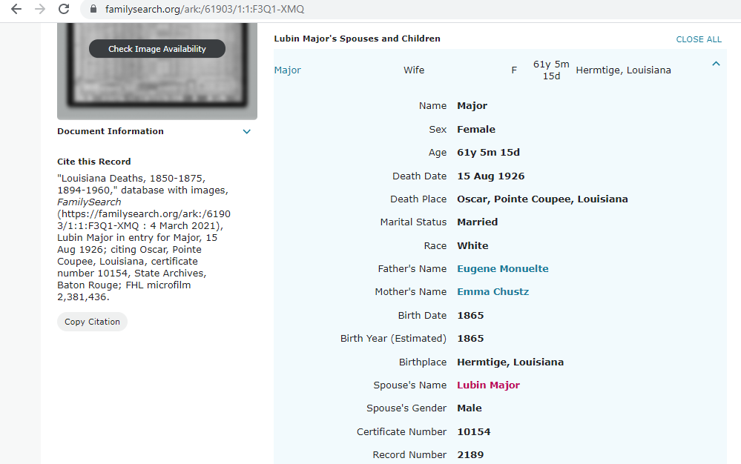
FHL Film #2381436
Certificate #10154

FHL Film #1221973
Certificate #177

